Advancing Generative AI Architectures: Exploring Multi-modal GANs and Diffusion Models- A Review
Dr. Samir Nasruddin Ajani¹, Prof Dr Midhunchakkaravarthy², Dr. Mudassir Khan³
¹School of Computer Science & Engineering , Ramdeobaba University (RBU), Nagpur, India ; ²Lincoln University College (LUC), Malaysia ; ³King Khalid University, Saudi Arabia
samir.ajani@gmail.com
Abstract: Recent progress in generative AI, especially Multi-modal Generative Adversarial Networks (GANs) and diffusion models, has shown that it is possible to combine high-quality, varied data from many different fields in ways that have never been seen before. This review looks at the big improvements in multi-modal GANs and diffusion models; focussing on how flexible they are when it comes to handling and combining data from different types of media, like text, pictures, and sounds. Multi-modal GANs are known for their creative cross-modal focus processes and modality-specific producers that make the merged data much more useful and high-quality. On the other hand, diffusion models are known for being reliable and making high-quality samples. This is mostly because of new developments in conditional diffusion models that make production processes more precise and managed. The review talks about problems like training steadiness and computer efficiency, and it also offers study that might be done in the future. This review of new research and case studies shows how these generative models can change things. They can be used to create data on their own, improve creative designs, and create more realistic simulation environments. The goal is to get more research done to make the most of these powerful tools.
Keywords: Generative Adversarial Networks, Diffusion Models, Multi-modal AI, Cross-modal Synthesis, AI Architecture
Introduction
Generative artificial intelligence designs especially Generative Adversarial Networks (GANs) and diffusion models have entirely revolutionised the area of artificial intelligence by including fresh, more sophisticated methods to mix and transform data. These models may provide fresh data somewhat comparable to that seen in the actual world. Making art, medical imaging, and even self-driving automobiles are just a few of the revolutionary applications for this in many spheres. This paper covers in great depth diffusion models and multi-modal GANs. It looks at their methods, their development, and how they may be used to enable robots to do task before unattainable. Since they launched GANs in 2014, Goodfellow et al. have altered computer understanding and creation of data. GANs are essentially based on two neural networks competing in a manner akin to game theory [1]. The discriminator network seeks to distinguish actual data from synthetic data; the generator network seeks to produce data that cannot be distinguished from real data. This competitive approach produces excellent, realistic data. Text, images, and music are just a few of the many kinds of data from which GANs excel at managing and mixing. When included into multi-modal applications, they often make the produced material more accurate and relevant [2].
However, diffusion models are a younger sort of generative fashions that display how information is slowly built up from a random spread of noise. Diffusion models, in contrast to GANs, create information by way of gaining knowledge of a repetitive manner of denoising, which improves the quality of the facts over some of steps. Plenty of people like those models because they are stable for the duration of training and the output is frequently higher than that of GANs. While used on multi-modal data, diffusion models offer a sturdy framework for coping with complex relationships and distributions between one-of-a-kind varieties of data. This makes them best for responsibilities that want best-grained manage over the advent technique [3]. While GANs and diffusion fashions are used together in a multi-modal context, the great functions of each are used to resolve the problems of cross-modal information advent. Multi-modal GANs can make statistics this is consistent across distinctive modalities by way of recognising and taking advantage of ways modalities depend on every different. As an instance, making a scene in a video game might involve putting collectively audio, video, and textual content reasons that every one play at the identical time and tell the equal story. The repeated denoising technique of multi-modal diffusion fashions can enhance the fact and complexity of this kind of synthesised statistics, making sure that the end output is both diverse and truly complicated [4]. Current enhancements to those generative designs have been made to cause them to greater efficient, scalable, and higher at making statistics. New features within the structure, like pass-modal interest methods, help the models cognizance on important elements of different types of facts, which makes the effects more contextually aligned. Also, methods to make the schooling method more solid in GANs and the processing faster in diffusion fashions have been very important in making those models able to take care of larger datasets and greater complicated technology responsibilities.
2. Theoretical Background
2.1 Generative Adversarial Networks (GANs)
Generative Adversarial Networks (GANs), which were created by Ian Goodfellow and his friends in 2014, are now one of the best ways to make fake data. A GAN is made up of two separate neural networks, which are called the generator and the discriminator. Starting with a random noise distribution, the generator's job is to make data that can't be told apart from real data. On the other hand, the discriminator checks the data it gets by telling the difference between real data from the training set and fake data made by the creator. This setup creates a dynamic, game-like environment where the generator is always learning how to make better fake data, while the discriminator is always learning how to spot fakes [5]. This pushes the whole system towards producing highly realistic data by switching between optimising the discriminator and the generator. It is taught to be as accurate as possible at telling the difference between real and fake data, which is a lot like teaching a computer to be a critical thinker. At the same time, the generator is set up to trick the discriminator by making data that looks more and more real. These hostile training stops when the generator makes data that is so believable that the discriminator can't tell the difference between real and fake data anymore. This is called a Nash equilibrium [6].
2.2 Diffusion Model
Diffusion models, a type of generative models that has become more popular lately, work very differently from GANs. An idea from statistical physics is used in these models to make data by turning a diffusion process around. At first, noise is slowly added to the data until only random noise is left. Through a series of conditional generation steps, the model learns to reverse this noise addition process in order to make new data. In this backwards process, each step depends on the one before it, and the data is slowly cleaned up until a clean sample is made. Usually, the goal of training is set up as a variation inference problem. This means that the model has to find the best parameters so that it has the best chance of finding the original data from the noisy versions. This method works especially well for making high-quality, detailed pictures and other types of complicated data [8].
Table 1: Differences between Generative Adversarial Networks (GANs) and diffusion models
Parameter | Generative Adversarial Networks (GANs) | Diffusion Models
Mechanism | Consists of two networks: a generator and a discriminator that compete in a game-theoretic approach. The generator creates data aiming to fool the discriminator, which tries to distinguish real from generated data. [10] | Operates by gradually adding noise to data and then learning to reverse this process to recreate the original data from the noise, through an iterative process.
Key Finding | Effective at generating high-quality, realistic data quickly but can suffer from training instability and mode collapse. [11] | Capable of producing extremely high-quality data with high levels of detail and fewer artifacts than GANs, though generally slower due to iterative nature.
Output Quality | Can generate highly realistic images, videos, etc., but may sometimes produce noticeable artifacts or fail to capture subtle details. [12] | Outputs are typically of very high quality with significant attention to detail, making them ideal for applications requiring high fidelity.
Computation Efficiency | Relatively efficient computationally, capable of generating outputs quickly once trained, suitable for real-time applications. [13] | Less efficient computationally, requiring many iterative steps and substantial processing power, which may not be suitable for real-time generation.
Application | Widely used in image and video generation, style transfer, and more recently, in tasks requiring synthesis of realistic human-like features. [14] | Increasingly used in scientific imaging, medical image analysis, and other fields where precise, detailed output generation is crucial.
Limitation | Prone to issues like mode collapse, where the model fails to capture diversity of the dataset, and sometimes faces training stability issues. [15] | Requires significant computational resources and time, which can limit its usability in time-sensitive or resource-constrained environments.
3. Advancements in Multi-modal GANs
3.1 Architectural Innovations
Cross-modal focus processes are one of the most important design changes in multi-modal GANs. When these processes work together, they make it easier for the model to focus on and combine important information from different modes, which makes the results more coherent and useful. Cross-modal attention lets the creator focus on certain aspects of one mode based on clues from another, which makes it possible to combine multi-modal data in a more detailed way.
In reality, cross-modal attention in GANs works by lining up and giving different modal traits equal weight. For instance, in a GAN that is meant to make video and sound that play at the same time, the attention mechanism might focus on lip movements as visible cues to make speech sounds in the audio that match. This selective interest allows the version make results where the modalities aren't solely present however also have essential relationships with every other. This makes the information extra practical and useful. Lots of research has shown that these forms of awareness techniques are useful for duties that want a deep understanding of how exclusive sorts of statistics relate to each other, like computerized video labelling and multi-modal translation [16]. In this situation, the eye system can alternate at the fly which audio or written elements are most important when growing visible content that is going with them. This makes the results extra correct and appropriate for the scenario. Adding those functions to GAN designs makes it a lot higher at dealing with large, complicated datasets with multiple inputs and outputs.
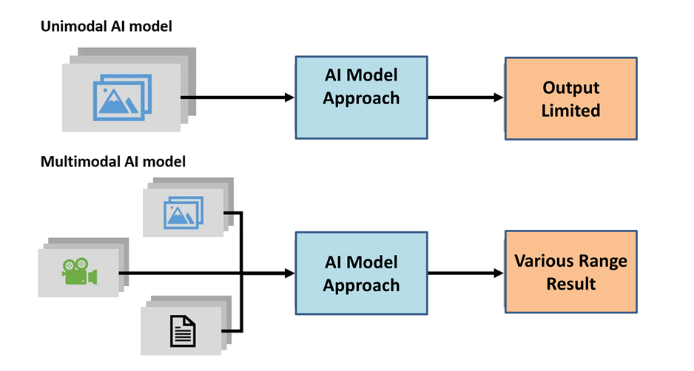
Figure 1: Comparison of Unimodal and Multimodal AI Model Capabilities
It also creates new opportunities for AI-pushed content introduction and records enhancement. The figure 1 shows how unimodal and multimodal AI models are distinctive from every different. The unimodal AI model can only deal with one kind of records, so it is able to solely produce positive results. The combined AI version, on the other hand, takes in exceptional sorts of information, like textual content, voice, and images, so it is able to come up with a much broader range of consequences. This indicates how multimodal systems can help with tough duties that need combining data from unique resources to make solutions which are extra whole and flexible.
3.2 Application Areas
A. Art and Creative Media
Multi-modal GANs had been used in art and creative media in essential ways which have modified how artists and architects reflect on consideration on idea. Those models have made it viable to make complicated inventive cloth like track, visible art, or even interactive media via using the potential to examine and create data across exceptional modes. As an instance, GANs can be used to make virtual photos that change based on the tempo and mood of the music [20]. This combination makes it viable for a brand new way of expressing yourself via combining video elements in approaches that have been tough or impossible to do with the aid of hand before. Multi-modal GANs have an impact on movie and video manufacturing due to the fact they can make sound consequences or speech that are life like and in shape the scene by using looking at visible clues. this option is available in on hand in cool animated film films and video games, in which smooth audio and video alignment is essential for growing a fascinating tale. The use of those sorts of apps now not only quickens manufacturing, but also improves creative sketch via letting artists attempt out complicated interactions between various senses.
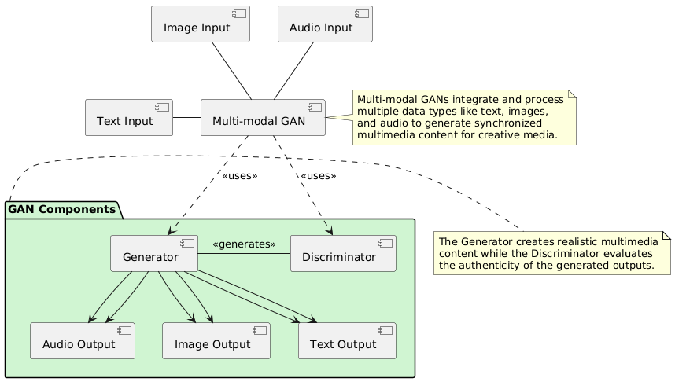
Figure 2: Overview of Multi-modal GANs in Art and Creative Media
B. Data Augmentation in Machine Learning
In machine learning, data enrichment is a key method for making models more reliable and accurate by making the training dataset bigger than it really is. Multi-modal GANs are very good at this because they can make fake data that stays realistic across different modes. For example, in healthcare, GANs can create labelled medical pictures that go with matching written clinical reports. This adds to datasets in situations where it might not be possible or safe to collect all real-world data. These skills are very useful in fields that need a lot of different kinds of data, like automatic driving systems. Multi-modal GANs can mimic different real-life situations, creating data that helps teach drive algorithms how to safely handle a wide range of unexpected situations. Multi-modal GANs help machine learning models generalise better by giving them a wider range of training cases.
Table 3: Analysis of multi-modal GANs are utilized for data augmentation in machine learning
Parameter | Description in Healthcare | Description in Autonomous Driving
Type of Data Generated [17] | Medical images with matching clinical reports | Simulated sensor data representing various environmental conditions
Purpose of Data Augmentation [18] | To augment the dataset where real medical data collection is restricted due to privacy concerns or the rarity of certain conditions. | To provide a diverse range of driving scenarios for training, ensuring that the system can handle unexpected real-world conditions.
Impact on Model Training [19] | Enhances the ability of diagnostic models to identify and predict medical conditions accurately. | Improves the robustness and safety of driving algorithms by exposing them to a wide range of simulated real-world situations.
Key Benefit [10] | Allows for the training of medical models on rare conditions, improving diagnostic accuracy and potentially patient outcomes. | Enables extensive testing and training without the risks and costs associated with real-world data collection in varied environments.
Challenges [20] | Ensuring the generated data accurately reflects complex medical conditions; managing the ethical implications of synthetic data. | Ensuring realistic simulation of environmental and sensor variables to provide truly valuable training data.

4. Advancements in Diffusion Models
4.1 Improvements in Model Efficiency
A. Techniques to reduce computational requirements
One important area for improvement in diffusion models is making them less demanding on computers. In the beginning, these models needed a lot of repeated steps to make good data. This made them slow and hard to compute, especially when compared to other generative models like GANs. To solve these problems, academics have come up with a number of ways to make diffusion models work better and be useful in more situations [24]. Enhancing the sample process is a popular method for cutting down on the number of rounds needed without lowering the quality of the output. Most of the time, this optimisation means learning shorter Markov chains or making the noise forecast more accurate at each step, both of which directly lower the computing load. Subsampling steps during training and inference are one technique that has shown promise in cutting down processing times while keeping the quality of the output. Learnt guidance strategies are another way to cut down on the amount of computing that needs to be done. In these strategies, a secondary network is taught to guide the main diffusion process, which speeds up convergence. This plan uses extra networks to figure out the best ways to move through the diffusion process, which cuts down on the number of steps needed to make a result that makes sense. Using these methods has made diffusion models easier to understand and use, especially in real-time situations where speed is important, like in interactive art pieces or real-time video improvements [25].
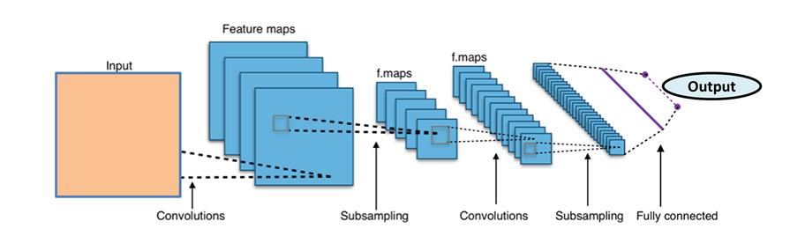
Figure 3: Overview of Diffusion model ML based
A convolutional neural network (CNN)'s spread model design is shown in Figure 3. The process starts with an input that goes through a number of convolutional layers. These layers make feature maps that show the most important parts of the data. Then, these are subsampled to lower the number of dimensions. More convolutions and subsampling follow, and finally, the final result come from a fully connected layer. This process does a good job of extracting and condensing data, which is important for tasks like recognising patterns and images.
4.2 Multi-modal Applications
A. Controlled Generation in Medical Imaging
In scientific imaging, diffusion models have proven numerous promises, mainly with regards to their ability to do manage era jobs. These models are very correct at putting together clinical photos that may trade in a deliberate method based totally on controlled inputs, like exclusive ranges of a disease or different affected person information. This feature could be very useful in conditions where data is restrained or wherein privacy worries need to be addressed. As an instance, it could be used to create a wide variety of abnormal snap shots that may be used to instruct diagnosis algorithms besides violating the privateness of sufferers. In diffusion fashions, the managed generation procedure consists of making the synthesis depend on certain clinical situations or developments. This makes it possible to make clinical images which can be very genuine and complete of detail. for example, a model might be taught to make X-rays that show how a sickness like tuberculosis gets worse through the years. This would provide useful information for training and study without the need for large patient files [13].
Figure 4: Key aspect for Controlled Generation in Medical Imaging
This app helps with medical training and study, and it also helps with the creation of personalised medicine methods by modelling how different treatments will work for different patients. Figure 4 probably shows a method or technology used for controlled generation in medical imaging. It might have something to do with a convolutional neural network or another type of machine learning model. These kinds of systems are very important for making thorough, reliable medical pictures from a variety of sources, which makes diagnosis easier. Controlled generation helps to mimic conditions that are unique to each patient. This makes personalised medicine easier and provides high-quality fake data for training healthcare workers. This improves treatment plans and medical research without compromising patient privacy.
Table 4: Comparison of multi-modal GANs and diffusion models
Parameter | Approach | Model Used | Key Finding | AI Model Used | Application | Limitation
Output Quality [11] | Multi-modal GANs | Generative Adversarial Networks | Capable of blending multiple modalities seamlessly, good for synchronized multimedia. | GANs with multi-modal capabilities | Creative media, entertainment, advertising. | Sometimes generates less realistic artifacts compared to diffusion models.
Output Quality [14] | Diffusion Models | Diffusion-based generative models | High-fidelity and detailed outputs with fewer artifacts, excellent at handling complexity. | Diffusion models | Medical imaging, scientific simulations, virtual reality | Computationally intensive, often requiring many iterative refinements.
Training Efficiency [15] | Multi-modal GANs | Generative Adversarial Networks | Training can be unstable and requires significant tuning and resources. | GANs with multi-modal capabilities | Training diverse data sets for AI applications. | Prone to mode collapse and can be resource-intensive.
Training Efficiency [21] | Diffusion Models | Diffusion-based generative models | Innovations have reduced training times, but still require high computational power. | Diffusion models | High-resolution applications where detail is crucial. | Generally slower and more resource-intensive than GANs.
Application Suitability [23] | Multi-modal GANs | Generative Adversarial Networks | Excellently suits applications requiring integration of text, images, and sound. | GANs with multi-modal capabilities | Automated storytelling, multimedia content creation. | May struggle with highly detailed or resolution-intensive tasks.
Application Suitability [24] | Diffusion Models | Diffusion-based generative models | Ideal for applications demanding the highest quality and precision. | Diffusion models | Detailed medical imaging, high-quality virtual environments | High computational requirements limit real-time applications.

7. Conclusion
This review discuss about the look at of multi-modal GANs and diffusion models. It suggests a large breakthrough in understanding a way to combine complicated facts from exclusive modes, which makes it feasible to apply these fashions in real life in ways that had been difficult earlier than. Multi-modal GANs are extremely good at connecting data streams, which is very helpful in fields that need multi-modal interactions to paintings well collectively. on the other hand, diffusion fashions provide you with a structured thanks to make high-fidelity outputs, that's important for packages that want to be very precise, like medical imaging. These technological advances no longer only make it simpler for AI to deal with and create specific types of data, but in addition they make it possible for brand spanking new apps to be created in many distinct areas. But troubles like scale, strength financial system, and moral issues want to be stored in thought all of the time. In the future, researchers should work on making these models more computationally efficient, creating mixed systems that use the best parts of both GANs and diffusion models, and making sure that generative technologies are used in a responsible way. Accepting these approaches is very important for progressing the field of generative AI and making the most of its huge potential to change how we use and gain from AI in many areas.
References
- Li, C.; Zhang, C.; Waghwase, A.; Lee, L.H.; Rameau, F.; Yang, Y.; Bae, S.H.; Hong, C.S. Generative AI meets 3D: A Survey on Text-to-3D in AIGC Era. arXiv 2023, arXiv:2305.06131.
- Dwivedi, Y.K.; Kshetri, N.; Hughes, L.; Slade, E.L.; Jeyaraj, A.; Kar, A.K.; Baabdullah, A.M.; Koohang, A.; Raghavan, V.; Ahuja, M.; et al. “So what if ChatGPT wrote it?” Multidisciplinary perspectives on opportunities, challenges and implications of generative conversational AI for research, practice and policy. Int. J. Inf. Manag. 2023, 71, 102642.
- Danel, T.; Łęski, J.; Podlewska, S.; Podolak, I.T. Docking-based generative approaches in the search for new drug candidates. Drug Discov. Today 2023, 28, 103439.
- Gozalo-Brizuela, R.; Garrido-Merchán, E.C. A survey of Generative AI Applications. arXiv 2023, arXiv:2306.02781.
- Gozalo-Brizuela, R.; Garrido-Merchan, E.C. ChatGPT is not all you need. A State of the Art Review of large Generative AI models. arXiv 2023, arXiv:2301.04655.
- Liu, Y.; Yang, Z.; Yu, Z.; Liu, Z.; Liu, D.; Lin, H.; Li, M.; Ma, S.; Avdeev, M.; Shi, S. Generative artificial intelligence and its applications in materials science: Current situation and future perspectives. J. Mater. 2023, 9, 798–816.
- Thoppilan, R.; De Freitas, D.; Hall, J.; Shazeer, N.; Kulshreshtha, A.; Cheng, H.T.; Jin, A.; Bos, T.; Baker, L.; Du, Y.; et al. Lamda: Language models for dialog applications. arXiv 2022, arXiv:2201.08239.
- Schick, T.; Dwivedi-Yu, J.; Jiang, Z.; Petroni, F.; Lewis, P.; Izacard, G.; You, Q.; Nalmpantis, C.; Grave, E.; Riedel, S. PEER: A Collaborative Language Model. arXiv 2022, arXiv:2208.11663.
- Li, Y.; Choi, D.; Chung, J.; Kushman, N.; Schrittwieser, J.; Leblond, R.; Eccles, T.; Keeling, J.; Gimeno, F.; Dal Lago, A.; et al. Competition-level code generation with alphacode. Science 2022, 378, 1092–1097.
- Sauer, A.; Lorenz, D.; Blattmann, A.; Rombach, R. Adversarial diffusion distillation. arXiv 2023, arXiv:2311.17042.
- Song, Y.; Durkan, C.; Murray, I.; Ermon, S. Maximum likelihood training of score-based diffusion models. Adv. Neural Inf. Process. Syst. 2021, 34, 1415–1428.
- Gu, S.; Chen, D.; Bao, J.; Wen, F.; Zhang, B.; Chen, D.; Yuan, L.; Guo, B. Vector quantized diffusion model for text-to-image synthesis. In Proceedings of the IEEE/CVF Conference on Computer Vision and Pattern Recognition, New Orleans, LA, USA, 18–24 June 2022; pp. 10696–10706.
- Xu, M.; Yu, L.; Song, Y.; Shi, C.; Ermon, S.; Tang, J. Geodiff: A geometric diffusion model for molecular conformation generation. arXiv 2022, arXiv:2203.02923.
- Rezende, D.J.; Mohamed, S.; Wierstra, D. Stochastic backpropagation and approximate inference in deep generative models. In Proceedings of the International Conference on Machine Learning, PMLR, Beijing, China, 22–24 June 2014; pp. 1278–1286.
- Khachatryan, L.; Movsisyan, A.; Tadevosyan, V.; Henschel, R.; Wang, Z.; Navasardyan, S.; Shi, H. Text2video-zero: Text-to-image diffusion models are zero-shot video generators. arXiv 2023, arXiv:2303.13439.
- Singer, U.; Polyak, A.; Hayes, T.; Yin, X.; An, J.; Zhang, S.; Hu, Q.; Yang, H.; Ashual, O.; Gafni, O.; et al. Make-a-video: Text-to-video generation without text-video data. arXiv 2022, arXiv:2209.14792.
- Lin, C.H.; Gao, J.; Tang, L.; Takikawa, T.; Zeng, X.; Huang, X.; Kreis, K.; Fidler, S.; Liu, M.Y.; Lin, T.Y. Magic3d: High-resolution text-to-3d content creation. In Proceedings of the IEEE/CVF Conference on Computer Vision and Pattern Recognition, Vancouver, BC, Canada, 17–24 June 2023; pp. 300–309.
- Jabbar, A.; Li, X.; Omar, B. A survey on generative adversarial networks: Variants, applications, and training. ACM Comput. Surv. CSUR 2021, 54, 1–49.
- Aggarwal, A.; Mittal, M.; Battineni, G. Generative adversarial network: An overview of theory and applications. Int. J. Inf. Manag. Data Insights 2021, 1, 100004.
- Ko, K.; Lee, M. ZIGNeRF: Zero-shot 3D Scene Representation with Invertible Generative Neural Radiance Fields. arXiv 2023, arXiv:2306.02741.
- Yinka-Banjo, C.; Ugot, O.A. A review of generative adversarial networks and its application in cybersecurity. Artif. Intell. Rev. 2020, 53, 1721–1736.
- Cai, Z.; Xiong, Z.; Xu, H.; Wang, P.; Li, W.; Pan, Y. Generative adversarial networks: A survey toward private and secure applications. ACM Comput. Surv. CSUR 2021, 54, 1–38.
- Chen, Y.; Yang, X.H.; Wei, Z.; Heidari, A.A.; Zheng, N.; Li, Z.; Chen, H.; Hu, H.; Zhou, Q.; Guan, Q. Generative adversarial networks in medical image augmentation: A review. Comput. Biol. Med. 2022, 54, 105382.
- Lu, Y.; Chen, D.; Olaniyi, E.; Huang, Y. Generative adversarial networks (GANs) for image augmentation in agriculture: A systematic review. Comput. Electron. Agric. 2022, 200, 107208.
- Singh, N.K.; Raza, K. Medical image generation using generative adversarial networks: A review. In Health Informatics: A Computational Perspective in Healthcare; Springer: Berlin/Heidelberg, Germany, 2021; pp. 77–96.
- Ko, K.; Yeom, T.; Lee, M. Superstargan: Generative adversarial networks for image-to-image translation in large-scale domains. Neural Netw. 2023, 162, 330–339.

