Proceedings S.Z.M.C. Vol: 39(1): pp. 12-18, 2025. PSZMC-965-39-1-2025

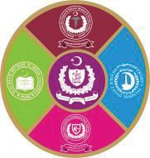
Social Media Usage Pattern and Its Impact on

Academic Performance of Public-Sector Medical Students
¹Hafiz Muhammad Ahtisam Idrees, ¹Fariha Salman, ¹Rozina Shahadat Khan, ¹Arshia
Mansha, ¹Musfira ¹ Musfira Habib, ¹Muhammad Shoaib, ¹Risha Naeem
ABSTRACT
Introduction: Social media plays a vital role in students' lives, providing connectivity and access to information while posing distraction risks.
Aims and Objectives: This study aimed to evaluate social media usage patterns and their impact on academic performance among medical students in Lahore.
Place and Duration of study: This study took place in public sector medical colleges of Lahore in 6 months from April to September 2024.
Material & Methods: This was an analytical cross-sectional questionnaire-based study conducted among 150 medical students of different medical colleges including KEMU, AMC, FJMU, AIMC, SIMS & SKZMDC selected through convenience sampling in Lahore. Data collected through the questionnaire included demographics, social media usage patterns, and academic performance indicators. The impact of social media usage on academic performance was determined by applying Chi-square with statistical significance determined at a p-value of less than 0.05. Data analysis was performed using SPSS version 27.
Results: Regarding social media use specifically for academic purposes, YouTube was the most popular platform, used by 119 participants (79.3%) followed by WhatsApp by 54 participants (36%). Average screen time of over 4 hours per day was reported by 78.7%, with maximum before going to bed (96%) and over the weekend (77.3%), main uses were entertainment in 86.7% and academics in 54.7%. Only one variable spending more than 04 academically directed hours on social media led to better examination performance in the male gender (p value<0.05).
Conclusion: The male gender spending more than 04 hours on social media for educational purposes had a positive impact on academic performance

Keywords: Academic Performance, Impact of Social Media, Social Media, Medical Students

INTRODUCTION
Social media represents a group of Internet-based applications that enable the creation and exchange of user-generated content, offering a platform for individuals to express themselves, share their experiences, and connect with others¹. The rise of social media has significantly altered the way people interact, transforming it into an indispensable part of daily life. Many individuals, particularly the younger generation, spend substantial hours each day on platforms such as Messenger, Instagram, Facebook, and others, engaging in various forms of communication and content sharing².

¹Ameer-ud-Din Medical College/PGMI, Lahore.
Correspondence:
Hafiz Muhammad Ahtisam Idrees, 4th Year MBBS, Ameer-ud-Din Medical College, Lahore
E-mail: ahtisamidrees16@gmail.com

Submission Date:4th September 2024 1st Revision Date: 15th January, 2025 Acceptance Date: 11th March, 2025

The accessibility and convenience of these platforms have made them an essential tool for maintaining relationships, seeking entertainment, and accessing information. Social media plays an important role in the sharing of information, enabling the rapid spread of news, ideas, and opinions across the globe ³. For students, social media offers enhanced interaction and communication with peers ⁴. It serves as a valuable resource for academic purposes. They can connect with peers from different regions, share resources related to academic courses, and participate in discussions about educational interests. However, the convenience of social media also comes with disadvantages. Notifications and the constant temptation to check for updates can interrupt study sessions, decreasing focus and productivity. Sleep deprivation, often caused by late-night social media use, further impairs concentration ⁵.
Medical students in Pakistan, like their counterparts worldwide, are increasingly adopting these platforms, which offer both opportunities and challenges ⁶. Although social media provides



potential benefits for learning, such as increasing access to educational resources and facilitating communication⁷, there are concerns regarding its potential negative influence on academic performance. Distractions from social media are a common issue, and some studies have pointed out its adverse effects on students' focus and productivity⁸. In Pakistan, a high percentage of medical students actively engage with social media platforms like YouTube, WhatsApp, and Facebook, with similar usage patterns as observed in the entire world ^{9,10}. Research on the link between social media use and academic performance among medical students has provided mixed results. Some studies emphasize the negative impacts on academic focus and overall performance^{8,11,12}. On the other hand, other research has highlighted the benefits of social media in supporting learning, such as through teamwork, access to information, and the sharing of academic content^{7,13–16}. Diverse findings of previously published studies put forward that social media's starring role in education is intricate and multidimensional. Furthermore, existing studies might not fully capture the details of social media use and its impact on the Pakistani medical education system^{6,17,18}. This study aimed to assess the pattern of social media use and academic performance among medical students of Lahore and to determine the association between social media usage patterns and academic performance. The study can be beneficial for medical institutes in developing policies to promote reasonable social media use for academic purposes. It can also help students revisit their time management strategies while using social media.

MATERIAL AND METHODS
Analytical cross-sectional study was conducted among 4th-year MBBS students of public sector medical colleges of Lahore, over a period of 6 months from April to September 2024 after the approval of Ethical Board Committee of Ameer Ud Din Medical College Lahore (Ref 00-35-A-2024, dated 06-06-24). Students who were on academic leave during the study period and who did not use social media were excluded from the study. Sample size of 150 from a population of 1400 was calculated using online calculator keeping confidence level at 95%, margin of error 5% and population proportion 87.7% ¹⁶ . The questionnaire was designed after an extensive literature search and pretesting was done to further improve its quality. Data was collected using a pre-designed, pretested structured online questionnaire administered via
Google Forms. Informed consent was obtained, and subjects were enrolled by non-probability convenience sampling fulfilling the inclusion and exclusion criteria, until the required sample size was achieved. The questionnaire comprised sections on demographics, social media usage patterns, and academic performance. Data analysis was performed using SPSS version 27. Regarding descriptive statistics, mean and standard deviation were calculated for age and marks in Professional exam. Frequencies and percentages were computed for categorical variables; number of social media accounts, frequency of checking social media, average time spent on social media per day, usage during lectures, social media usage while traveling, social media use before bed, social media usage on weekends, limiting social media use before/ during exams & primary reason for social media use. For the evaluation of academic performance, students were classified into two categories based on their marks. Students who scored less than or equal to 75% were considered to have below-average academic performance, while those scoring 75% or higher were categorized as above-average performers. Chi-square test was utilized to find the relationship between social media usage patterns and academic performance. A significance level of p
< 0.05 was set for all statistical tests.

RESULTS
The study included 150 medical students, with a mean age of 22.19 years (SD = 0.979). Of the participants, 82 (54.7%) were male, while 68 (45.3%) were female. In terms of living arrangements, 78 students (52%) identified as day scholars and 72 students (48%) as hostilities. Regarding family background, a significant proportion of students, 120 (80%), came from urban areas, while 30 students (20%) hailed from rural backgrounds.(Table-01).
The frequency of use for various social media platforms highlights significant differences between general and academic usage for platforms like Facebook, Twitter, Instagram, YouTube, and LinkedIn. Facebook and Instagram were primarily used for general purposes (p < 0.05). WhatsApp was used relatively evenly for both general and academic purposes (p = 0.081). YouTube was significantly more used for academic purposes than for general use (p < 0.05).(Table-02)
In contrast, variables such as the number of social media accounts, frequency of checking social media, and usage during lectures or travel showed no significant association with academic

performance. (Table 03). Students who spent more than 4 hours per day on social media exhibited significantly higher academic performance, as indicated by a greater proportion of students achieving marks above 75% (p = 0.022). This positive trend was particularly evident among those using social media primarily for academic purposes, where longer usage durations were associated with better marks (p = 0.015). Similarly, male students who spent over 4 hours on social media also demonstrated significantly higher performance compared to those with less usage (p = 0.04).
(Table-3)
TABLE 01: Sociodemographics
Category | Details | Number of Students (N) | Percentage (%)
Gender | Male | 82 | 54.7
Gender | Female | 68 | 45.3
Institutions | Ameer-Ud- Din Medical  College | 82 | 54.7
Institutions | Fatima Jinnah Medical University | 25 | 16.7
Institutions | Allama Iqbal Medical College | 10 | 6.7
Institutions | King Edward Medical  University | 11 | 7.3
Institutions | Services Institute of Medical Sciences | 11 | 7.3
Institutions | Sheikh Khalifa Bin Zayed Al Nahyan Medical & Dental  College | 11 | 7.3
Living  Arrangements | Day Scholars | 78 | 52.0
Living  Arrangements | Hostellites | 72 | 48.0
Family Background | Urban | 120 | 80.0
Family Background | Rural | 30 | 20.0
Family Structure | Nuclear Family | 81 | 54.0
Family Structure | Joint Family | 41 | 27.3
Family Structure | Single-Parent Family | 27 | 18.0
Family Structure | Extended Family | 1 | 0.7

Table 02: Comparison of Social Media Platforms

Platform | General Use (Frequency) N=150 | Academic Use (Frequency) N=150 | p- value
Facebook | 67 | 8 | 0.012*
Twitter | 18 | 10 | 0.001*
Instagram | 118 | 28 | 0.042*
WhatsApp | 129 | 54 | 0.081
YouTube | 102 | 119 | 0.009*
LinkedIn | 10 | 9 | 0.000*
Other | 0 | 6 | 0.838
*Significant, p-value = <0.05

Reasons for using social media is depicted in Figure 01. The social media usage patterns among participants revealed that a significant majority had five or fewer accounts and frequently checked social media more than four times daily. Additionally, a substantial proportion used social media for extended periods, especially before bed, while many reported limiting their usage during exams.
(Table 04).

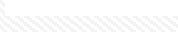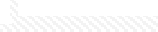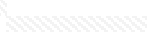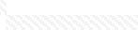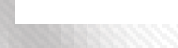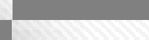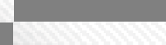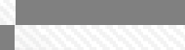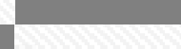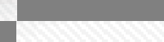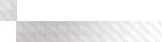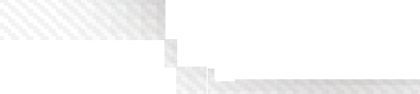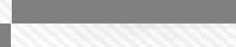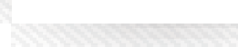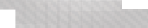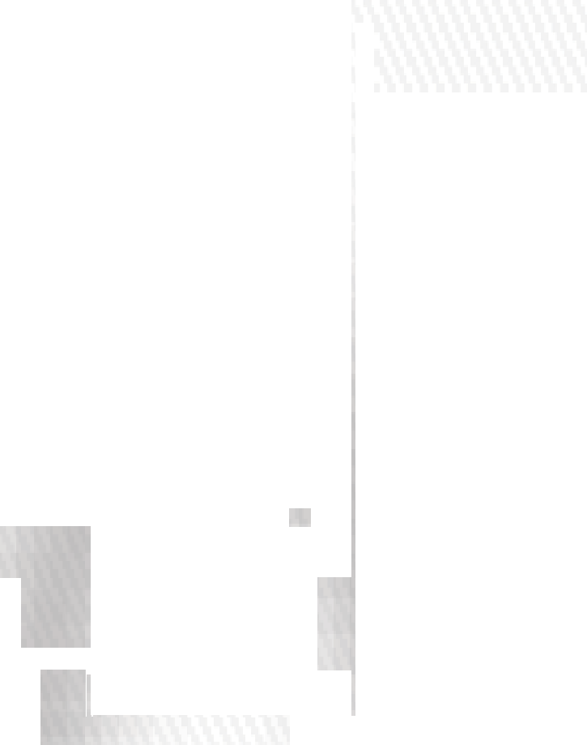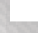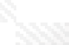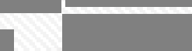
Figure 01: Reasons for
use social media
6%0%
20%
33%
20%
21%
Entertainment
Academic Purposes Socializing
Staying Updated with News
Networking for Professional Connections Other

TABLE 03: Social Media Impact on Academic Performance
Variable | Subcategory | Marks in Professional exam |  | Chi-  squa re | P  valu e
Variable | Subcategory | < 75% N=72(%) | >75% N=78 (%) |  | P  valu e
No of social media accounts | <5 | 59(49.6) | 60  (50.4) | 0.57 | 0.45
No of social media accounts | >5 | 13(41.9) | 18  (58.1) | 0.57 | 0.45
Frequency of checking social media | < 4 times | 21(42.9) | 28  (57.1) | 0.77 | 0.38
Frequency of checking social media | >4times | 51(50.5) | 50  (49.5)
Hours spent on social  media per day | < 4 hrs | 43(57.3) | 32  (42.7) | 5.23 | 0.02  2*
Hours spent on social  media per day | >4hrs | 29(38.7) | 46  (61.3)
Social media use during lectures | No | 39(50.6) | 38  (49.4) | 0.45 | 0.50
Social media use during lectures | Yes | 33(45.2) | 40  (54.8)
Social media use while traveling | No | 38(47.5) | 42  (52.5) | 0.02 | 0.89
Social media use while traveling | Yes | 34(48.6) | 36  (51.4)
Social media use before bed | No | 2(33.3) | 4  (66.7) | 0.54 | 0.68
Social media use before bed | Yes | 70(48.6) | 74  (51.4)
Increase use of social  media over the weekend | No | 14(41.2) | 20  (58.8) | 0.82 | 0.36
Increase use of social  media over the weekend | Yes | 58(50.0) | 58  (50.0)
Limiting social media  use during exams | No | 9(40.9) | 13  (59.1) | 0.52 | 0.47
Limiting social media  use during exams | Yes | 63(49.2) | 65  (50.8)
Missed classes due to social media | No | 52(46.0) | 61  (54.0) | 0.72 | 0.39
Missed classes due to social media | Yes | 20(54.1) | 17  (45.9)
Used primarily for entertainment | No | 12(60.0) | 8  (40.0) | 1.33 | 0.25
Used primarily for entertainment | Yes | 60(46.2) | 70  (53.8)
Used primarily for academics | No | 29(42.6) | 39  (57.4) | 1.43 | 0.23
Used primarily for academics | Yes | 43(52.4) | 39  (47.6)
Used primarily for academics- Yes-Hours spent on social media per day  N=43 | < 4 hrs | 30(63.8) | 17  (36.2) | 5.73 | 0.01  5*
 | >4hrs | 13(37.1) | 22  (62.9)
Male Gender- Hours spent on social  media per day N=82 | < 4 hrs | 25(61.0) | 16  (39.0) | 3.95 | 0.04  *
 | >4hrs | 16(39.0) | 25  (61.0)
* Significant, p-value = <0.05

TABLE 04: Social Media Usage Pattern
Category | Details | (N) | (%)
Number of Social Media Accounts | Five or fewer | 119 | 79.3
Number of Social Media Accounts | More than five | 31 | 20.7
Frequency of Checking Social Media | More than four times per day | 101 | 67.3
Frequency of Checking Social Media | 3-4 times per day | 27 | 18
Frequency of Checking Social Media | 1-2 times per day | 19 | 12.7
Frequency of Checking Social Media | Less than once per day | 3 | 2
Average Time Spent on Social Media per Day | More than 4 hours | 75 | 50
Average Time Spent on Social Media per Day | 3-4 hours | 50 | 33.3
Average Time Spent on Social Media per Day | 1-2 hours | 21 | 14
Average Time Spent on Social Media per Day | Less than 1 hour | 4 | 2.7
Usage During Lectures | Yes | 73 | 48.7
Usage During Lectures | No | 77 | 51.3
Social Media  Usage While Traveling | Yes | 70 | 46.7
Social Media  Usage While Traveling | No | 80 | 53.3
Social Media Use Before Bed | Yes | 144 | 96
Social Media Use Before Bed | No | 6 | 4
Social Media Usage on Weekends | More on weekends | 116 | 77.3
Social Media Usage on Weekends | No change | 34 | 22.7
Limiting Social Media Use Before/ During Exams | Yes | 128 | 85.3
Limiting Social Media Use Before/ During Exams | No | 22 | 14.7

DISCUSSION
The focus of this study was to assess the pattern and extent of social media use among students in Lahore, identify the primary reasons for their social media use, and evaluate the association between social media usage patterns and academic performance as measured by their previous year's obtained marks. This study found WhatsApp (86%) and YouTube (68%) to be the most popular platforms among participants. These findings align with studies from India¹⁹ and Saudi Arabia¹¹ where WhatsApp and YouTube dominate. In Bangladesh (70.1%)²⁰, Turkey (95.3%)²¹, Vietnam²², and Ireland²³ Facebook remains the leading platform. About the use of social media for academic purposes, YouTube emerged as the most popular platform, used by 119 participants (79.3%), followed by WhatsApp, which was used by 54 participants (36%). This finding is consistent with a systematic review of 26 countries, which identified YouTube and WhatsApp as the most favored

platforms for educational content²⁴. In our study, 86.7% of students reported using social media for entertainment, while 54.7% used it for academic purposes. This finding aligns with research from India, where 80% of students cited entertainment as their primary use²⁵, and is lower than the 95.8% reported in Saudi Arabia¹¹. Regarding academic use, our results exceed a meta-analysis showing a range of 20%¹⁰ but fall short of Vietnam's nearly universal rate of 99.7% for learning²². Our findings are comparable to the 40% in Saudi Arabia¹¹ and 44.7% in Bangladesh²⁰. These findings illustrate a significant reliance on social media for entertainment among students, with academic use reflecting regional disparities, suggesting cultural influences and varying integration of social media in educational contexts across different countries.
The notably high frequency and duration of social media usage among students in our study, particularly the two-thirds checking platforms over four times daily and 83.3% spending more than three hours, suggest a concerning trend that may significantly impact their time management and academic performance, especially in comparison to lower engagement levels observed in regions like Jordan²⁶, Sharjah²⁷, and Saudi Arabia²⁸. In the present study, about half of the students used social media during lectures, while almost all used it before bed. These results align with high in-class usage reported in India²⁵ but differ from Sharjah²⁷ and Madina²⁸, where over 85% of students use social media during lectures. Similarly, the pre- bedtime usage in our study is significantly higher than the 68% observed in Saudi Arabia²⁹.
In our study, 16% of participants reported a positive impact of social media on their academics, while 20% noted a negative impact, and 57.3% experienced both. This contrasts with findings from Madina, where 56.3% of students identified social media as a distraction²⁸. Notably, 66.6% of our participants viewed social media as an effective learning tool, aligning with 85% of Indian students who found it engaging for academic purposes²⁵ and 95.8% of Saudi students recognizing its benefits for academic progress¹⁶. Furthermore, 84% of our respondents recommended social media for educational use, consistent with over 75% of students in India advocating for its academic application²⁵. These positive perceptions suggest that the role of social media as a valuable educational resource is increasingly acknowledged across various cultural contexts.
The study's findings reveal an unexpected positive correlation between social media usage and academic performance, indicating that students who
spend more than 4 hours per day on social media primarily for academic purposes achieve significantly higher exam scores, with a notable proportion exceeding 75% (p = 0.022). This trend is particularly strong among those who use social media primarily for academic purposes, where longer usage is linked to better marks (p = 0.015). Additionally, male students engaging with social media for over 4 hours daily also perform significantly better than their peers (p = 0.04).
Findings of the present study challenge the notion of detrimental effects of social media on academics, suggesting that fair, guided and responsible use of social media that is to use for academic purposes leads to better performance. So, integrating media use in teaching and learning strategies will be a good addition and can be a great help for tech- oriented generations who are already spending enough time on devices.
Cross sectional study design, smaller sample size, limited settings, self-reported data were the limitations of the study that may have introduced bias. Further studies with analytical study designs and larger sample size are recommend establishing causality and validate findings.

CONCLUSION
This study emphasized the intuitive relationship between social media usage and academic performance. Among the social media usage pattern, 04 hours spent per day on social media had a positive impact on academic performance in male gender and among those who used social media for education purpose challenging the acceptable belief of deleterious effects.

REFERENCES
- Barman L, Mukhopadhyay DK, Bandyopadhyay GK. Use of Social Networking Site and Mental Disorders among Medical Students in Kolkata, West Bengal. Indian J Psychiatry 2018;60(3):340–345.
- Karim F, Oyewande AA, Abdalla LF, Chaudhry Ehsanullah R, Khan S. Social Media Use and Its Connection to Mental Health: A Systematic Review. Cureus 2020;12(6):e8627.
- Zafar H, Mobin MB. Excessive usage of social media: A potential threat to mental health in Pakistan. J Pak Med Assoc 2024;74(1):201.
- Ravi D, Chandran S, Sreedaran P. Social Media Use for the Dissemination of Mental Health Information by Medical Students. Journal of Psychiatry Spectrum [homepage on the Internet] 2022;1(2). Available from: https://journals.lww.com/jops/fulltext/2022/07000/so cial_media_use_for_the_dissemination_of_mental.1 0.aspx

- Nazari A, Hosseinnia M, Torkian S, Garmaroudi G. Social media and mental health in students: a cross- sectional study during the Covid-19 pandemic. BMC Psychiatry 2023;23(1):458.
- Social Media Usage and its Association with Academic Performance of Undergraduate Physical Therapy Students | The Healer Journal of Physiotherapy and Rehabilitation Sciences [Homepage on the Internet]. [cited 2024 Aug 19];Available from:
https://www.thehealerjournal.com/index.php/templat es/article/view/100
- Singh N, Lehnert K, Bostick K. Global Social Media Usage: Insights Into Reaching Consumers Worldwide. Thunderbird International Business Review 2012;54.
- Bulut GÇ, Gokce S. Problematic social media use, digital gaming addiction and excessive screen time among Turkish adolescents during remote schooling: implications on mental and academic well-being. Marmara Medical Journal [homepage on the Internet] 2023;Available from: https://api.semanticscholar.org/CorpusID:256447086
- Lau WW. Effects of social media usage and social media multitasking on the academic performance of university students. Computers in human behavior 2017;68:286–291.
- Guraya SY. The Usage of Social Networking Sites by Medical Students for Educational Purposes: A Meta-analysis and Systematic Review. N Am J Med Sci 2016;8(7):268–278.
- Alfaris EA, Irfan F, Ponnamperuma G, et al. The pattern of social media use and its association with academic performance among medical students. Medical Teacher 2018;40:S77–S82.
- Owusu-Acheaw M, Larson AG. Use of Social Media and its Impact on Academic Performance of Tertiary Institution Students: A Study of Students of Koforidua Polytechnic, Ghana. Journal of Education and Practice 2015;
- Avcı K, Çelikden SG, Eren S, Aydenizöz D. Assessment of medical students’ attitudes on social media use in medicine: a cross-sectional study. BMC Medical Education [homepage on the Internet] 2015;15. Available from: https://api.semanticscholar.org/CorpusID:1238141
- George DR, Dellasega C. Social media in medical education: two innovative pilot studies. Med Educ 2011;45(11):1158–1159.
- Kaur S, Manhas R. Use of Social Media among Medical Teachers and Students of Punjab, India: A Study. Asian Journal of Information Science and Technology [homepage on the Internet] 2018;Available from:
https://api.semanticscholar.org/CorpusID:239795560
- Alsuraihi AK, Almaqati AS, Abughanim SA, Jastaniah NA. Use of social media in education among medical students in Saudi Arabia. Korean Journal of Medical Education 2016;28:343–354.
- Students’ Perspective on Prospect of Anatomy Education in Bangladesh Through E-learning Using Social Media as a Complementary Tool | Bangladesh Journal of Medical Education [Homepage on the Internet]. [cited 2024 Aug 19];Available from: https://lamjol.info/index.php/BJME/article/view/709 48
- The Role of Social Media in Proliferating Violent Behavior Among College Students in District Layyah, Pakistan | Review of Applied Management and Social Sciences [Homepage on the Internet]. [cited 2024 Aug 19];Available from: https://ramss.spcrd.org/index.php/ramss/article/view/ 266
- Bhandarkar AM, Pandey AK, Nayak R, Pujary K, Kumar A. Impact of social media on the academic performance of undergraduate medical students. Med J Armed Forces India 2021;77(Suppl 1):S37–S41.
- Begum H, Asaduzzaman AKM, Talukder HK, Nargis T, Alam KK, Asadullah. Use of Social Media by the Undergraduate Medical Students: Students’ Perception in Selected Medical Colleges of Bangladesh. Bangladesh Journal of Medical Education [homepage on the Internet] 2018;Available from:
https://api.semanticscholar.org/CorpusID:158871246
- Kadriye Avcı, S. G. Çelikden, S. Eren, Doğukan Aydenizöz. Assessment of medical students’ attitudes on social media use in medicine: a cross- sectional study. BMC Medical Education [homepage on the Internet] 2015;15. Available from: https://consensus.app/papers/assessment-students- attitudes-media-medicine-study- avc%C4%B1/0ca61022598556cca0572bdd83f01548
- Bich Diep P, Minh Phuong V, Dang Chinh N, Thi Hong Diem N, Bao Giang K. Health Science Students’ Use of Social Media for Educational Purposes: A Sample from a Medical University in Hanoi, Vietnam. Health Serv Insights 2021;14:11786329211013549.
- Bickerdike A, O’Deasmhunaigh C, O’Flynn S, O’Tuathaigh C. Learning strategies, study habits and social networking activity of undergraduate medical students. Int J Med Educ 2016;7:230–236.
- Guckian J, Utukuri M, Asif A, et al. Social media in undergraduate medical education: A systematic review. Med Educ 2021;55(11):1227–1241.
- Farghal NS, Islam MS, Dasnadi SP, Alteneiji SO, Awheed AM. The Impact of Social Media on Professional Learning among Undergraduate Dental Students: A Cross-sectional Study. J Contemp Dent Pract 2023;24(11):877–886.
- Saadeh RA, Saadeh NA, Torre MA de la. Determining the usage of social media for medical information by the medical and dental students in northern Jordan. J Taibah Univ Med Sci 2020;15(2):110–115.
- Alnjadat R, Hmaidi MM, Samha TE, Kilani MM, Hasswan AM. Gender variations in social media usage and academic performance among the students

of University of Sharjah. J Taibah Univ Med Sci 2019;14(4):390–394.
- Alshanqiti A, Alharbi OA, Ismaeel DM, Abuanq L. Social Media Usage and Academic Performance Among Medical Students in Medina, Saudi Arabia. Adv Med Educ Pract 2023;14:1401–1412.
- Kolhar M, Kazi RNA, Alameen A. Effect of social media use on learning, social interactions, and sleep duration among university students. Saudi J Biol Sci 2021;28(4):2216–2222.

The Authors:
Hafiz Muhammad Ahtisam Idrees 4th Year MBBS,
Ameer-ud-Din Medical College, Lahore
Dr. Fariha Salman Assistant Professor
Ameer-ud-Din Medical College/PGMI, Lahore
Dr. Rozina Shahadat Khan Associate Professor/HOD
Ameer-ud-Din Medical College/PGMI, Lahore
Arshia Mansha 4th Year MBBS,
Ameer-ud-Din Medical College, Lahore
Musfira Habib 4th Year MBBS,
Ameer-ud-Din Medical College, Lahore
Muhammad Shoaib 4th Year MBBS
Ameer-ud-Din Medical College, Lahore
Risha Naeem 4th Year MBBS,
Ameer-ud-Din Medical College, Lahore
Authorship:
HMAI: Conception of idea, data analysis, literature review, write-up
FS: Data analysis write-up RSK: Revision, Approval AM: Data Collection
MH: Data Collection MS: Data Collection RN: Data Collection

