GEOGRAPHICAL ANALYSIS OF THE ONION MARKET, A CASE STUDY OF PARNER APMC, AHILYANAGAR DISTRICT, MAHARASHTRA, INDIA
Dr. Dattatray Sheshrao Ghungarde
Associate Professor, Department of Geography,
New Arts, Commerce and Science College, Parner, Dist - Ahmednagar
Email: dsghungarde@gmail.com Mobile No: 9822572733

--------------------------------------------------------------------------------------------------------------------

ABSTRACT:
Agriculture plays a pivotal role in shaping India’s economic structure and rural livelihood. Among the various agricultural commodities, onion (Allium cepa L.) occupies a unique position as both a staple food ingredient and a major cash crop. It is indispensable to Indian cuisine and also contributes significantly to export earnings. However, onion markets are known for their high degree of price volatility, influenced by climatic conditions, seasonality, inadequate storage infrastructure, and fluctuating supply chains.
India is the second-largest producer of onions in the world after China, contributing nearly 20% of global production. Maharashtra, particularly the Nashik and Ahilyanagar districts, dominates onion production and marketing in the country. The crop’s dual role—providing both food and income—makes its geographical and economic analysis particularly important.
From a geographical standpoint, studying the onion market in Parner provides valuable insights into agro-economic spatial interactions, market linkages, and regional development patterns. This analysis emphasizes the interrelation between physical environment, agricultural productivity, and market infrastructure, highlighting the necessity of integrated market planning and modernization.
Thus, the present research Paper aims to examine the functional and spatial characteristics of the onion market, evaluate economic performance trends, and suggest measures for sustainable market management.
Keywords: Onion Market, Parner APMC, Agricultural Economics, Price Fluctuation, Market Infrastructure, Supply Chain, Ahilyanagar District, Maharashtra, Agricultural Geography, Perishable Crop.

1.Introduction
Onion is important vegetable used by all relation and all over the world onion is used for taste and flavor it is majority used for presentation of Masala. Onion is a crop for all seasons. Rabi onion is harvested during summer and having think layers. Its life is only 6 to 8 months. Whereas kharif onion are harvested during October November. Onion has high moisture contents and it has a thin skin layer so onion is highly perishable.
The onion crop is perishable and there is risk in storage of onion. There is weight loss and loss of onion quantity by 10% to 15% so price goes high in the wholesale and retail market of onion.
India is the second largest producer of onion in the world, next to china and ranks third in export of onion. During 2001-2002, a total of lack matric tones of bulbs was produced from an area of 4.96 lack hectors in India. Maharashtra is the leading onion producing state in India followed by the Karnataka and Gujarat. The crop grown on extensive scale in Orissa, Andre Pradesh, Uttar Pradesh, Tamilnadu, and Bihar.
The Parner Onion Market, located in the semi-arid region of Ahilyanagar District, has emerged as a crucial trading hub for onion growers. The town’s proximity to major production centers, improved road connectivity, and functioning under the Agricultural Produce Market Committee (APMC) framework have contributed to its growth. Yet, seasonal fluctuations, inadequate cold storage facilities, and infrastructural limitations continue to challenge market stability and farmer income.

2. STUDY AREA
The study area selected for the research is Parner town, located in the Ahilyanagar District of Maharashtra. Geographically, Parner lies at 19°0′0″N latitude and 74°26′0″E longitude, with an elevation of approximately 790 meters above mean sea level. The town covers about 5,520 hectares, while the larger Parner Tehsil spans 1,930.28 square kilometers. According to the 2011 Census, the population of Parner town is around 25,000.

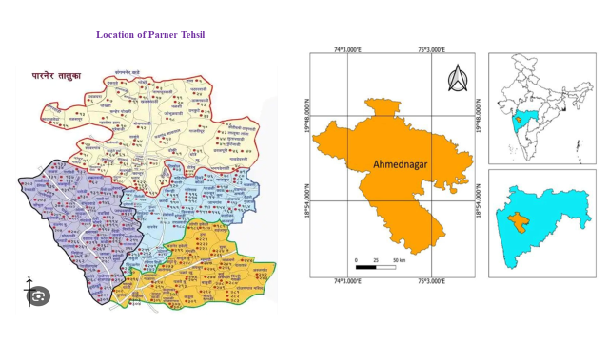
Map1: Location Map of Parner Tehsil, Ahilyanagar District
Parner lies in the Central Plateau Region of the Deccan Plateau, featuring a combination of flat plains and gently undulating topography. The area is characterized by limestone-rich soils, particularly in Nighoj, and lies within the rain shadow zone of the Western Ghats, receiving an average annual rainfall of 695 mm. The climate is moderate, with summer temperatures reaching up to 35°C and winter temperatures dropping to around 16°C.
The region’s land use pattern is predominantly agricultural, accounting for about 76.55% of the total area. Forests occupy 9.74%, while settlements and infrastructure make up the remaining 13.71%. The Bhima River basin and its tributaries, including the Kukadi River, define the hydrology of the area. Vegetation includes species like teak, neem, babul, mango, and tamarind.
The Parner Onion Market (APMC Parner) is situated within this geographical framework and serves as a focal point for trade in onions and other agricultural commodities. Established in 1981, the market plays a central role in regional agricultural commercialization.

3. OBJECTIVES
i)To examine the geographical factors influencing the Onion Market in Parner.
ii) To study the infrastructure and economic functioning of the Parner APMC Onion Market.
iii)To analyze seasonal price variations and their impact on farmers ‘income.
iv) To assess the role of government policies, market reforms, and technology in onion marketing.
v) To propose sustainable measures to enhance market efficiency and farmer profitability.

4. HYPOTHESIS
“Seasonal variations, supply chain inefficiencies, and government interventions significantly influence price volatility and market performance of onions in Parner APMC.”

5. RESEARCH METHODOLOGY
The study adopts a mixed-method approach, combining both quantitative and qualitative research techniques.
- Primary Data were collected through field visits, interviews with traders, farmers, and APMC officials, and on-site observation of market activities.
- Secondary Data were sourced from the Agricultural Department, APMC records, NABARD reports, FAO publications, CACP reports, and online databases such as DgMarket.
- Analytical Tools included graphical representation of market trends, tabulation of procurement and price data (2019–2025), and statistical analysis of seasonal variations.
- The study also used comparative and temporal analysis to understand fluctuations in prices and quantities procured.
The overall methodological framework aims to integrate spatial, economic, and institutional perspectives to present a comprehensive picture of the onion market.

6. ONION CROP
Onion (Allium cepa L.) is one of India’s most important commercial vegetable crops and an essential part of both domestic consumption and agricultural exports. It is cultivated across a wide range of climatic regions due to its adaptability and economic value. India is the second-largest producer of onions in the world, next to China, and ranks third in global exports. The major onion-producing states include Maharashtra, Karnataka, Madhya Pradesh, Gujarat, Rajasthan, Uttar Pradesh, and Andhra Pradesh, with Maharashtra leading production through regions like Nashik and Ahilyanagar. Onions are cultivated in three main seasons—Kharif, Late Kharif, and Rabi—of which the Rabi crop is the most important for its thicker layers and longer storage life. In areas like Parner, where climatic conditions are semi-arid, farmers prefer Rabi cultivation because it provides better yields and income stability.
Different varieties of onions are grown in India, such as N-53, Bhima Red, Bhima Super, Bhima Raj, Nasik Red, and Bellary Red, each suited to specific soil and climatic conditions. The crop grows best in cool weather during early growth and warm, dry conditions during maturity, ideally at temperatures between 20°C and 25°C. Onions prefer well-drained loamy to sandy loam soils with a pH of 6.0–7.5 and require frequent shallow irrigation, especially during bulb formation. Being a perishable crop, onion prices fluctuate widely due to seasonal gaps, poor storage, and climatic variation. The absence of cold-storage and transport infrastructure often leads to post-harvest losses, while government interventions such as export bans or subsidies temporarily stabilize prices. In this context, the Parner region plays an important role in onion production and trade, where both geographical and economic factors determine market behavior and farmer livelihoods.
7. GEOGRAPHICAL ANALYSIS ONION MARKET PARNER
The Parner Onion Market, functioning under the Agricultural Produce Market Committee (APMC), was established on 21 November 1981 after separating from the Parner Nagar Bazar Samiti. The market was developed under the guidance of Appasaheb Kisanrao Pawar, its first chairman, and today operates as one of the major onion trading centers in Ahilyanagar District, Maharashtra. Spread across 4 acres and 15 gunthas, it houses 29 sheds, godowns, and administrative buildings. Farmers from nearby talukas such as Parner, Shirur, Khed, Dhibada, and Sangamner bring their produce here, while traders arrive from Tamil Nadu, Andhra Pradesh, and Karnataka, indicating its inter-state significance. Onions are traded mainly between November and March, while crops like jowar and bajra dominate from April to August.
Over time, the Parner APMC has developed into a well-organized, modern market. It has implemented an online weighing and billing system, through which farmers receive instant transaction updates via mobile phones, ensuring transparency. The APMC has also established a grading and storage facility at Supa MIDC, equipped with a 1,000 metric ton capacity warehouse and grain-cleaning machinery. A petrol pump at the Bhalwani sub-market, operational since 2009, adds to its income, generating ₹30–40 lakh annually. The committee has invested ₹3.09 crore in fixed deposits with nationalized banks, showing sound financial management and stability.
The market’s financial performance demonstrates impressive growth. The total income rose from ₹1.77 crore in 2022–23 to ₹4.26 crore in 2024–25, while net profits increased from ₹27.94 lakh to ₹2.08 crore in the same period. The total market turnover for 2024–25 was approximately ₹426 crore, reflecting increased procurement and better cost control. Procurement volumes expanded from 9.7 lakh quintals in 2019–20 to 15.3 lakh quintals in 2024–25, while the average price per quintal increased from ₹1,550 (2021–22) to ₹2,570 (2024–25). The highest average price was recorded between September and December 2024, reaching ₹8,000–8,280 per quintal, whereas the lowest was in April–May 2020, when prices fell to ₹600–700 per quintal.
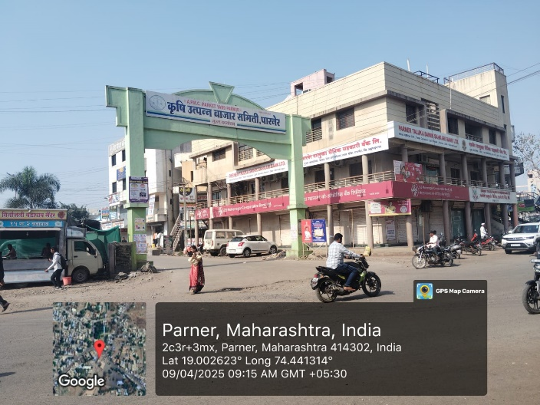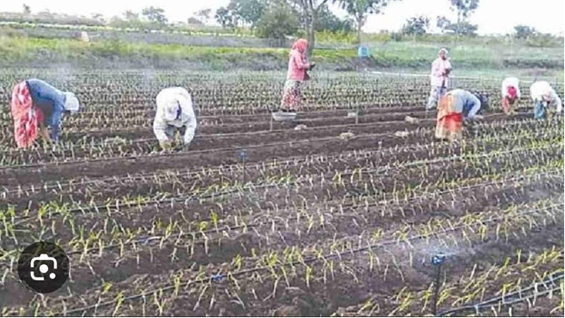
This consistent financial progress highlights the APMC’s efforts toward transparency, digitalization, and farmer welfare. The introduction of direct bank payments, electronic weighing systems, and low establishment costs (₹73 lakh) has made the Parner market one of the most efficient in the region. Moreover, initiatives like soybean procurement at government-fixed prices, along with immediate payments to farmers, demonstrate the committee’s commitment to fair trade practices. The APMC’s upgraded A2-Star rating further reflects its financial health and operational efficiency.
In summary, the Parner Onion Market represents a successful model of regional agricultural development, combining economic growth, transparency, and technological advancement. Its efficient management and farmer-centric policies have strengthened its role as a key market center in the semi-arid landscape of Maharashtra. However, despite these achievements, challenges such as price volatility, inadequate cold storage, and infrastructure gaps remain and require continued attention for the market’s sustainable growth.

8. FINDINGS
- The Parner Onion Market APMC, established in 1981, spans 4 acres and 15 gunthas of land with 29 sheds and well-developed trading infrastructure.
- The market’s annual turnover (2024–25) reached ₹426 crores, with a net profit of ₹2.08 crore, reflecting efficient financial management.
- The APMC has introduced an online weighing system, ensuring transparency for farmers.
- The market receives produce mainly from Parner, Shirur, Khed, Dhibada, and Sangamner, and serves traders from Tamil Nadu, Andhra Pradesh, and Karnataka.
- The average annual procurement increased from 9.7 lakh quintals (2019–20) to 15.3 lakh quintals (2024–25), showing continuous market expansion.
- Seasonal fluctuations remain significant, with peak arrivals during November–February.
- Infrastructure such as grading units, warehouses (1000 MT capacity), and petrol pumps at sub-markets like Bhalwani contribute to revenue diversification.

9. SUGGESTIONS
- Establish modern cold storage and warehousing facilities to reduce post-harvest losses.
- Encourage digital trading platforms and farmer cooperatives for better price realization.
- Improve transport and logistics between production zones and market yards.
- Introduce crop insurance and price stabilization funds for onion farmers.
- Strengthen market information systems and periodic price forecasting mechanisms.

10.CONCLUSION:
The geographical analysis of the Onion Market in Parner reveals that the market functions as a critical node in regional agricultural trade, integrating rural producers with urban and national supply chains. Despite financial growth and infrastructural improvements, the market remains vulnerable to seasonal shocks and inadequate storage systems.
A strategic focus on modernization, technology adoption, and policy coordination can transform Parner APMC into a model of sustainable and efficient agricultural marketing in Maharashtra. Sustainable market planning, when combined with farmer awareness and digital transparency, can ensure both profitability and resilience in the face of climatic and economic uncertainties.

REFERENCE
- Acharya, S.S. (2004). Agricultural Marketing in India. Oxford & IBH Publishing.
- ICAR (2016). Annual Report on Horticultural Crops.
- NABARD (2018). Post-Harvest Management and Storage Studies.
- Srivastava, R. et al. (2020). Supply Chain Issues in Perishable Commodities. Indian Journal of Agricultural Economics.
- FAO (2021). Market Integration and Food Price Stability.
- CACP (2019). Price Policy for Onion Farmers.
- RBI (2020). Agricultural Market Integration Report.
- DgMarket (2022). Digital Mandi and Price Data Portal.
- Parner APMC Reports (2019–2025).
- Field Observations and Survey Data (2024–25).

