IMPACT OF INCLUDING OVERTOPPING IN HYDRODYNAMIC MODELLING FOR COASTAL INUNDATION IN PORT PHILLIP BAY

Raymond C. Z. Cohen, CSIRO Data61, Raymond.Cohen@csiro.au
Julian O’Grady, CSIRO Oceans and Atmosphere, Julian.O’Grady@csiro.au
Mahesh Prakash, CSIRO Data61, Mahesh.Prakash@csiro.au
Kathy McInnes, CSIRO Oceans and Atmosphere, Kathleen.Mcinnes@csiro.au

BACKGROUND
During 2019-2021 CSIRO led the Port Phillip Bay Coastal Hazard Assessment (PPBCHA) project, concerning the bay located in Victoria, Australia. This study looked into the three main hazards of inundation, erosion and groundwater. As part of the inundation hazard component, coastal inundation involving wave setup, seawall overtopping, drainage and urban flooding was considered. Computational modelling was the tool used to study these key elements, necessitating the development of a coupled hydrodynamic and overtopping model. This paper details the assessment of the overall flooding sensitivity to the inclusion of the overtopping modelling, surge (storm tide), rainfall, and drainage.

METHODS
The flood modelling for this project was undertaken using the CSIRO developed City-based Flood Adaptation Solutions Tool (CFAST) which is a Shallow Water Equation based solver (Prakash, et al. 2019). CFAST uses a finite volume approach, is GPU accelerated and is capable of modelling coastal inundation, surge or storm tides, rainfall on grid, river catchment flows and stormwater drainage. Since this project required modelling hundreds of kilometres of coastline, it was not feasible to model individual short waves. Since individual short waves are the main driver for sea wall overtopping, an empirical overtopping model based on the EurOtop equations was added as a sub-processor to the CFAST software (O’Grady, et al., 2019). The coupling was achieved by having overtopping discharge at a landward grid point from the coastal structure. The overtopping was only activated when the still water level (SWL) was between the toe and crest of the coastal structures.

RESULTS AND DISCUSSION
The sensitivity of the flooding extents to different elements of the modelling (including overtopping) was considered in this project. Figure 1 shows flooding extents for sea level rise (SLR) values of 0.0 m and 0.8 m along with both including and excluding overtopping modelling. For current sea level (SLR = 0.0 m) the model displays the known nuisance flooding expected behind the seawall along Beaconsfield Parade. This also highlights that overtopping will be more of an issue with increased SLR. Figure 2 quantifies flood impacted areas depending on the storm surge, inclusion of overtopping, rainfall scenario and inclusion of drainage modelling. Longer duration (lower intensity) 10% annual exceedance probability (AEP) rainfall events cause less flooding than shorter duration 10% AEP events. Inclusion of drainage modelling alleviates the flooding as expected.

SLR = 0.0 m | SLR = 0.8 m
Storm surge
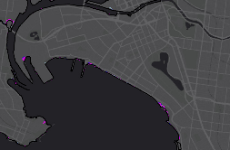 | 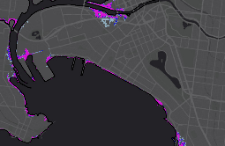
Storm surge + overtopping
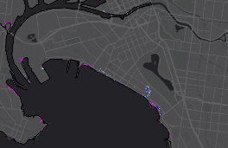 | 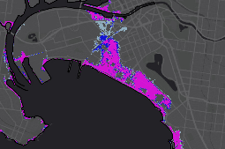
Figure 1 – Inundation flood extents (above 0.1 m) for 3 different 1% AEP storm surge likelihoods (pink 95%, dark blue 50% and light blue 5%).

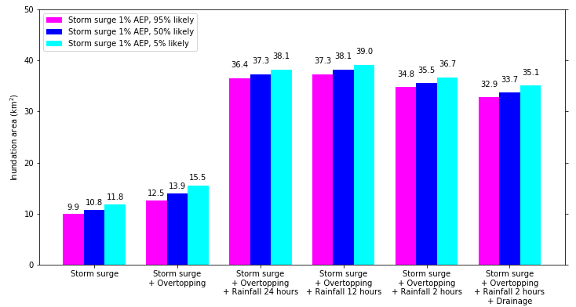
Figure 2 – Summary of flood inundation flood areas (above 0.1 m) for SLR = 0.0 m cases.

CONCLUSION
Seawall overtopping was found to be a critical modelling component to include for the coastal inundation assessment of Port Phillip Bay. Studying sensitivity to different modelling parameters provided additional key insights for stakeholders and decision makers.

REFERENCES
Prakash, et al. (2019). An evidence based approach to evaluating flood adaptation effectiveness including climate change considerations for coastal cities: City of Port Phillip, Victoria, Australia, J. Flood Risk Man., WILEY, vol 13.
O’Grady, et al. (2019) Wave Overtopping in the City Scale Coupled Hydrodynamic/Hydraulic Numerical Inundation Model: C-FAST. Australasian Coasts & Ports Conference, Hobart.

