PARTICIPATORY APPROACH TO ASSESS COASTAL EROSION MITIGATION AND CLIMATE CHANGE ADAPTATION MEASURES

Márcia Lima, RISCO & Civil Engineering Department, University of Aveiro, Lusophone University of Porto, marcia.lima@ua.pt
Carlos Coelho, RISCO & Civil Engineering Department, University of Aveiro, ccoelho@ua.pt
Filipe Alves, Faculty of Sciences of the University of Lisbon, fmalves@fc.ul.pt
André Vizinho, Faculty of Sciences of the University of Lisbon, afvizinho@fc.ul.pt

INTRODUCTION
The economic and social importance of coastal areas combined with their growing erosion problems and climate change impacts allows anticipating an increase in investments in these areas. In the past, strategies to mitigate territorial losses or property damage have been mainly reactive, non-inclusive, non-participatory, and locked-in technical solutions. Moreover, cost-benefit assessments of Coastal and Climate Change Adaptation (CCA) plans are still scarce, underused and poorly understood. So, the goal of this work is to contribute to a complete characterization of coastal erosion mitigation and climate change adaptation strategies and their implementation measures by considering a participatory approach that integrates medium to long-term perspectives, combining, simultaneously, social, environmental, economic and engineering dimensions, to help decision-makers implementing sustainable future-proof CCA strategies.

METHODOLOGY
The developed methodology is based on the working assumptions of the INCCA project (INtegrated Coastal Climate Change Adaptation for Resilient Communities, http://incca.web.ua.pt/). The INCCA project aims to perform a cost-benefit analysis of measures to mitigate coastal erosion and promote CCA within a time frame of short- (2025), medium- (2050) and long-term (2100); to assess local social-environmental impacts of CCA options; and to develop a participatory and economic model-based framework for CCA. Some of its objectives are: to identify and quantify the social, environmental and economic costs of possible adaptation measures (including long-term pathways shaped by the previous options); identify and quantify the potential social, environmental and economic benefits of adaptation measures; develop and use numerical models to forecast the shoreline evolution, the behavior of coastal structures, accounting for hazards (e.g. flooding), and performing the cost-benefit analysis (LTC, Coelho, 2005; COAST, Lima, 2018; and CEAS, Roebeling et al., 2018).
The main outputs of the project are an open source database of analyzed adaptation measures, costs, effectiveness and benefits, and a set of potential adaptation strategies suitable to implement along the worldwide sandy coastlines. These Mitigation and Adaptation Measures (MAM) account for context-specific social-environmental characteristics, implementation costs and potential economic, social and environmental benefits. The results involve stakeholders, who have assessed different options, created meaningful debates over different assumptions, and pointed in directions regarding a more quantitative evaluation of impacts.
The outcomes support the participatory co-design of adaptation pathways and tipping points from a short- medium- and long-term perspective. To obtain the MAM, several steps were considered: identify and quantify the technical, social, economic, and environmental coastal intervention’s negative impacts (costs); identify and quantify the benefits that can be obtained by applying different adaptation measures; and integrate this information to present a social-environmental and economic model that supports the development of efficient and effective coastal erosion mitigation and CCA.
Although in this work the methodology is applied to a specific case study in Portugal (Ovar), it is replicable to any other sedimentary coastal zones in Portugal or elsewhere.

RESULTS
Currently, the developed Manual includes 53 measures, characterized in 3 databases: Database #1 – MAM (Lima et al., 2021a); Database #2 - Impacts of MAM (Lima et al., 2021b); and Database #3 - Direct Costs of MAM (Lima et al., 2021c). The MAM’s databases can be updated (available at http://incca.web.ua.pt/) and the MAM’s classification defined in the INCCA project follows two main measures groups: group A, acting at the causes' level; group B, acting at the consequences' level. Each group presents three sub-groups, each of them with several different measures. In group A, the mitigation measures sub-groups are: 1) Reduction of the sediment deficit - a set of measures aiming at diminishing the deficit of sediments that reaches the coastal system, through rivers, or that are taken directly from the coastal zone (11 measures); 2) Regularization of the flow of sediments in the coastal system - a set of measures that aim to balance the flow of sediments, allowing its regularization (9 measures); and 3) Artificial nourishments - a set of measures aiming at adding sediments in the coastal system (9 measures). In group B, the sub-groups of adaptation measures are: 1) Protection with coastal structures - a set of measures that aim to protect infrastructure and assets from damages caused by the advance of the sea (11 measures); 2) Accommodation - a set of measures aiming at accommodating the littoral to coastal processes and erosion mechanisms (10 measures); and 3) Relocation and/or Removal - a set of measures that provide for relocation and/or removal, as a way of mitigating the risk of coastal erosion (3 measures).
For all measures, a total of 160 impacts were identified, combining positive and negative environmental (51), economic (50) and social (59) aspects.
CASE STUDY AND PARTICIPATORY MOMENTS
The participatory and economic model-based framework, as well as the design of the adaptation pathways, is being co-developed and applied in a pilot case study: Ovar Municipality (Figure 1). Ovar represents one of the most serious coastal erosion areas in Portugal (Coelho et al., 2015).
The pilot study region presents high erosion rates and sediment deficit, several coastal defense structures, different levels of land use (urban and forest), and issues related to tourism (camping, hotel, surf schools), fishing (relocation of a fisherman’s neighborhood), and environment (a sealed landfill is highly threatened by coastal erosion, leading to ecological concerns related to potential consequences). The participatory moments (e.g. focus groups and interviews, stakeholder analysis, scenario workshops) were performed at this study site, in order to develop and test the framework.

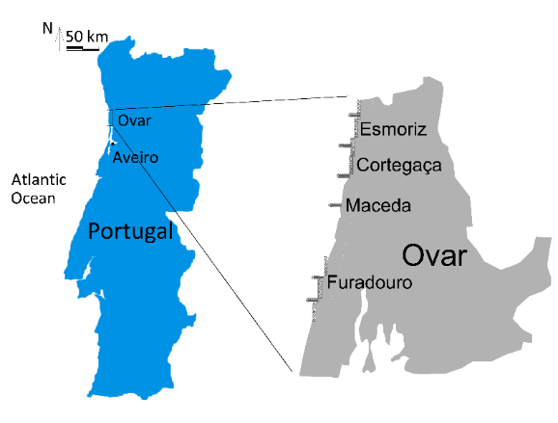
Figure 1 – Study area location (Cruz et al., 2015).

All the Mitigation and Adaptation Measures of the developed databases were discussed in participatory workshops, and the stakeholders’ group included central administration, local authorities, academia, national institutes and individuals of several economic activities, like surf and camping, etc.
Under the INCCA project, three participatory workshops have already taken place: 1st Participatory Workshop - "Strategies, costs and benefits" (Alves et al., 2021); 2nd Participatory Workshop – “Scenarios for the Territory” (Rato et al., 2021); and the 3rd Participatory Workshop – “Adaptation Pathways” (Alves et al., 2022). The first participatory event (Figure 2), held entirely in an online format (due to the pandemic situation of Covid), was divided into 3 different moments: the 1st moment, with the objective of analyzing and prioritizing foreseen mitigation and adaptation measures (Lima et al., 2021d) - held in November 2020, which brought together 21 participants; the 2nd moment with the goal of carrying out multi-criteria and cost-benefit analysis to the set of measures discussed on in the first moment - held in December 2020, which brought together 24 participants; and the 3rd moment with the goal of validating the impacts of each MAM and their related metrics - held in May 2021, which also brought together 24 participants.
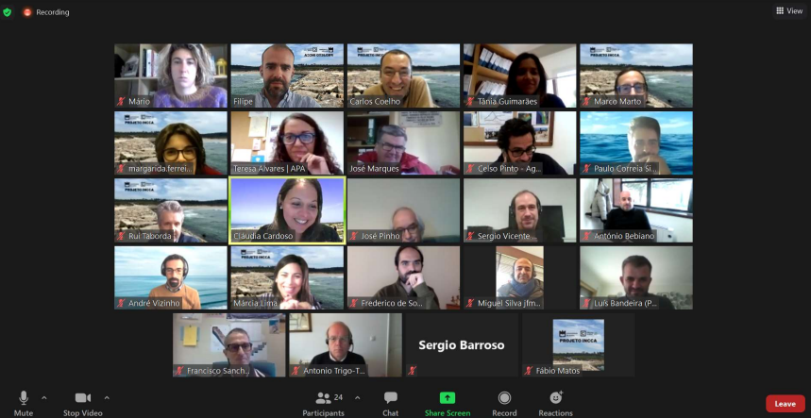
Figure 2 – 1st Participatory Workshop (held entirely in an online format).

The 2nd and 3rd Participatory Workshops have applied the SWAP (Scenario Workshop & Adaptation Pathways) participatory method (Vizinho et al., 2017), concerning the goal of adaptation to coastal erosion and climate change. This methodology was divided into two parts: the first part of the SWAP was developed in the second participatory event, held in October 2021 (with 27 participants, Figure 3) and the second part, was established in the third participatory event, in April 2022 (with 26 participants, Figure 4).

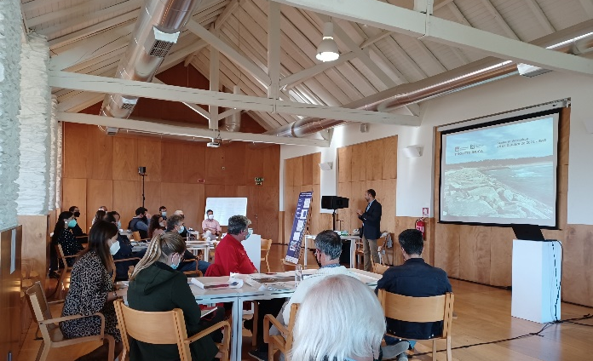
Figure 3 – 2nd Participatory Workshop (held in Ovar).

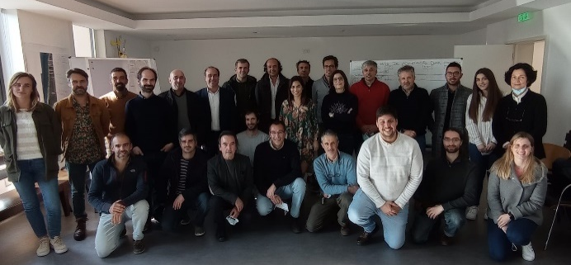
Figure 4 – 3rd Participatory Workshop (held in Cortegaça, Ovar).

A diverse set of stakeholders have attended all the participatory events, ensuring the diversity but also the continuity of ideas of the generality of the participants with responsibility over the management of coastal uses and the decision-making in the municipality of Ovar. The results obtained in each participatory moment were the basis for the subsequent workshops and will contribute to the Coastal Adaptation Plan for the Ovar Municipality (Alves, 2021).
CONCLUSIONS
The future coastal management will necessarily be different from what was the management of these territories throughout the 20th century. Changes are happening at the level of actors and institutions involved, but also in the decision-making processes, the funding model and in the complexity of solutions and their implementation. The growing human, economic and environmental pressure in these territories, as well as the requirments to combat and prevent increasingly frequent and damaging events, forces the needs to plan and act better, and in a more participated and integrated way. This increasingly complex management invites the use of new approaches of listening and involving populations, companies, organizations, the civil society and academia. Project INCCA main contribute is this new culture of coastal management, either by experimenting participatory methodologies, and by promoting and facilitating new inter and intra-stakeholders’ dynamics.
At the end, the outcome of this work aims to reduce the vulnerability of coastal territories and increase the resilience of local communities. The final product offers a participatory and economic model-based framework to support medium to long-term climate change adaptation action-plans that integrate a social-environmental systems perspective. INCCA's participatory methodology allowed generating processes and results that otherwise, would not be possible, aiming a more appropriated coastal management in the future. It is considered that the participatory approach and integrated framework has a global application in respect to methodologies and concepts and thus, the results are suitable to implement in the Portuguese coastline (or elsewhere). Furthermore, these participatory methodologies must be co-designed and context-specific, but the basic principles of their design and implementation are replicable and scalable. It is required that researchers undertake a proactive facilitator role by bringing together stakeholders, resolving conflicts, and promoting shared benefits for the entire community involved. The proposed approach is useful to help coastal management entities, leading to consensus, commitment and optimized solutions to mitigate coastal erosion and adapt to future climate change effects.

ACKNOWLEDGMENTS
This work was financially supported by the project “Integrated Coastal Climate Change Adaptation for Resilient Communities”, INCCA - POCI-01-0145-FEDER-030842, funded by FEDER, through “Competividade e Internacionalização” in its FEDER/FNR component and by national funds (OE), through FCT/MCTES. It was also supported by the Foundation for Science and Technology (FCT) - Aveiro Research Centre for Risks and Sustainability in Construction (RISCO), Universidade de Aveiro, Portugal [FCT/UIDB/ECI/04450/2020].

REFERENCES
Alves (2021): Relatório técnico do 1º workshop participativo do projecto INCCA: análise económica das medidas de mitigação e adaptação à erosão costeira no Concelho de Ovar, FCUL-UL, Lisboa.
Alves, F., Matos, F., Lima, M., Ferreira, M., Filho, L., Coelho, C. (2022): Relatório técnico do 3º Workshop Participativo: Dos Cenários para o Território aos Caminhos de Adaptação para Ovar, FCUL-UL, Lisboa.
Coelho, C. (2005): Riscos de Exposição de Frentes Urbanas para Diferentes Intervenções de Defesa Costeira (in Portuguese). Aveiro: University of Aveiro. 405p.
Coelho, C.; Pereira, C.; Costa, S.; Lima, M. (2015): A erosão costeira, as tempestades e as intervenções de defesa costeira no litoral do concelho de Ovar, Portugal, Ressacas do Mar/Temporais e Gestão Costeira (2015). 448 p. ISBN 978-85-7924-440-7 (in Portuguese).
Cruz, T. (2015): Análise Custo-Benefício de Obras Longitudinais Aderentes. Master thesis, University of Aveiro, Portugal, 140 p.
Lima, M. (2018): Ferramenta numérica de análise do impacto de intervenções de defesa costeira na evolução da linha de costa: custos e benefícios (in Portuguese). in Portugal, Aveiro: University of Aveiro2018. p. 294p.
Lima, M., Coelho, C., Alves, F., Marto, M. (2021a): Base de Dados #1 – Medidas de Mitigação e Adaptação à Erosão Costeira e às Alterações Climáticas, Projeto INCCA – Adaptação Integrada às Alterações Climáticas para Comunidades Resilientes (POCI-01-0145-FEDER-030842), Universidade de Aveiro.
Lima, M., Coelho, C., Alves, F., Marto, M. (2021b): Base de Dados #2 – Impactos de Medidas de Mitigação e Adaptação à Erosão Costeira e às Alterações Climáticas, Projeto INCCA – Adaptação Integrada às Alterações Climáticas para Comunidades Resilientes (POCI-01-0145-FEDER-030842), Universidade de Aveiro.
Lima, M., Coelho, C., Alves, F., Marto, M. (2021c): Base de Dados #3 – Custos de Medidas de Mitigação e Adaptação à Erosão Costeira e às Alterações Climáticas, Projeto INCCA – Adaptação Integrada às Alterações Climáticas para Comunidades Resilientes (POCI-01-0145-FEDER-030842), Universidade de Aveiro.
Lima, M., Alves, F. M., Marto, M., Coelho, C. (2021d): Mitigation and adaptation measures to coastal erosion and climate change effects. Revista Recursos Hídricos. Vol. 42, No. 1, 61- 70, APRH, ISSN 0870-1741 | DOI 10.5894/rh42n1-cti7.
Rato, D., Alves, F., Vizinho, A., Lima, M. Coelho, C. (2021): Relatório técnico do 2º workshop participativo do projecto INCCA: Análise de Cenários e Visões de Futuro para a Gestão Costeira no concelho de Ovar, FCUL-UL, Lisboa.
Roebeling, P., et al., Efficiency in the design of coastal erosion adaptation strategies: An environmental-economic modelling approach. Ocean and Coastal Management, 2018. 160: p. 175-184.
Vizinho, A., Campos, I., Coelho, C., Pereira, C., Roebeling, P., Alves, F., Rocha, J., Alves, M.F., Duarte-Santos, F., Penha-Lopes, G. (2018): SWAP - Participatory Planning of Coastal Adaptation to Climate Change. Journal of Integrated Coastal Management, 17(2): 99-116. DOI:10.5894/rgci-n48.

