COLLABORATIVE LIVING LABORATORIES TO INFORM CANADIAN DESIGN GUIDANCE FOR COASTAL NATURE-BASED SOLUTIONS

Danika van Proosdij, Saint Mary’s University, Canada, dvanproo@smu.ca
Enda Murphy, National Research Council Canada, University of Ottawa, Canada, enda.murphy@nrc-cnrc.gc.ca
Andrew Cornett, National Research Council Canada, University of Ottawa, Canada, acornet2@uottawa.ca
Ioan Nistor, University of Ottawa, Canada, inistor@uottawa.ca
Ryan Mulligan, Queen’s University, Canada, ryan.mulligan@queensu.ca
Michelle Côté, Natural Resources Canada-Geological Survey of Canada, Canada, michelle.cote@nrcan-rncan.gc.ca
Jacob Stolle, Institut national de la recherche scientifique, Canada, jacob.stolle@inrs.ca
Paul Knox, National Research Council Canada, Canada, paul.knox@nrc-cnrc.gc.ca
Scott Baker, National Research Council Canada, Canada, scott.baker@nrc-cnrc.gc.ca

INTRODUCTION
Nature-based solutions (NbS) have been widely applied for managing coastal flood and erosion risk (Bridges et al. 2021). However, they are underutilized in Canada, owing to a variety of factors including, e.g.: (i) uncertainty surrounding the performance of different nature-based solutions across Canada’s diverse coastal climates, geographies, and land uses; and (ii) the lack of authoritative, regionally appropriate design guidance (Vouk et al. 2021). The Nature-based Infrastructure for Coastal Resilience and Risk Reduction project is bringing together a multi-disciplinary team of Canadian researchers, practitioners, and community leaders to develop an improved understanding of the performance of nature-based shore protection systems in diverse Canadian coastal environments.
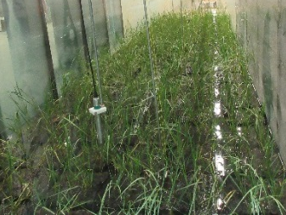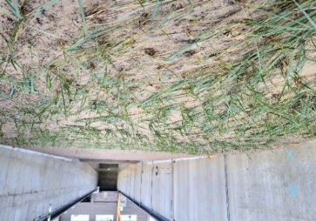
Figure 1 – Experiments with salt marsh vegetation native to Atlantic Canada at the National Research Council Canada, Ottawa (left) and Institut national de la recherche scientifique, Québec (right).

METHODOLOGY
The project involves conducting synchronized and coordinated parallel research activities – laboratory experiments (Fig. 1), field monitoring (Figs. 2 and 3), and numerical modelling – centered on multiple pilot sites along Canada’s Pacific and Atlantic coasts. The goals of the research are to develop:
- A unique knowledge base concerning the performance of NbS in Canadian coastal settings;
- New and improved analytical tools to predict and assess the performance of coastal NbS; and
- Design guidance for coastal NbS in Canada.
Research plans have been co-developed with local government and Indigenous community partners to leverage local and traditional knowledge, and ensure the findings help to shape planning, design, maintenance, and adaptive management of NbS at the pilot sites. NbS being considered or implemented include a wide range of solutions including a “Living Dyke”, dynamic revetments (cobble beaches), marsh restoration, managed dyke realignment, thin-layer placement, and a mega-nourishment “sand engine”.
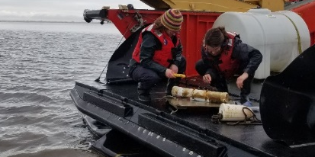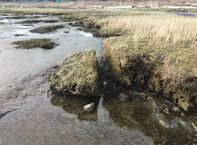
Figure 2 – Deploying wave sensors on a macro-tidal mudflat and marsh system, Boundary Bay, Pacific Canada.
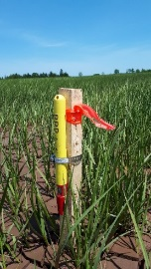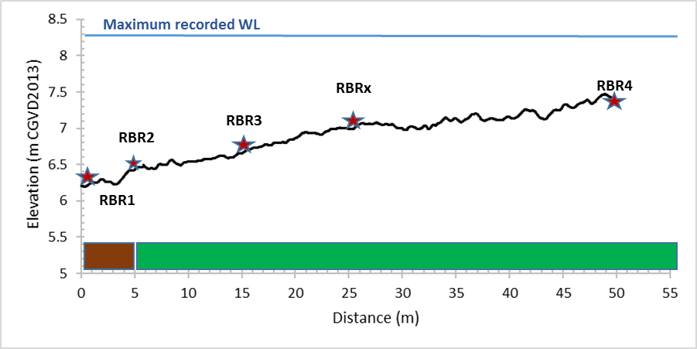
Figure 3 – Wave sensor array installed across a mega-tidal salt marsh system, Bay of Fundy, Atlantic Canada.

NOVEL FINDINGS AND NEXT STEPS
This research has already generated new knowledge to guide NbS implementation on Canada’s coasts, including: species- and site-specific influences on wave attenuation by native salt marsh vegetation under varying tidal regimes; the response of immature (newly planted) marsh plants to waves; marsh-dyke-wave interactions in hybrid systems; development and efficacy assessment of marsh plant surrogates for laboratory testing; high-resolution numerical models; and new design formulae for dynamic revetments. Drawing on lessons learned from the applied research within these “living laboratories”, a new Canadian design guide is being developed to complement international guidelines (Bridges et al. 2021), and to mobilize this new knowledge base surrounding the performance of NbS in distinct Canadian coastal settings.
REFERENCES
Bridges et al. (2021): International Guidelines on NNBF for Flood Risk Management. U.S. Army Engineer Research and Development Center.
Vouk, Pilechi, Provan, Murphy (2021): Nature-based Solutions for Coastal and Riverine Flood and Erosion Risk Management. Canadian Standards Association.

