ADAPTATION ASSESMENT OF PORT INFRASTRUCTURES FOR CLIMATE CHANGE FOR COMPOUND IMPACTS

Javier L. Lara, Instituto de Hidráulica Ambiental de Cantabria, lopezjav@unican.es
Alberto Fernandez, Instituto de Hidráulica Ambiental de Cantabria, alberto.fernandezperez@unican.es
Inigo J. Losada, Instituto de Hidráulica Ambiental de Cantabria, losadai@unican.es
David Lucio, Instituto de Hidráulica Ambiental de Cantabria, david.lucio@unican.es

INTRODUCTION
Extreme events, enhanced by Climate Change may cause several damages on coastal critical infrastructures, whereas port services are even more sensible to climatic stressors than those physical assets (UNECE, 2013). Therefore, consideration of Climate Change (CC) induced variability is necessary within adaptation assessment frameworks (IPCC, 2014) that evaluate the performance of both port services and assets under the affection of diverse climatic drivers.

METHODOLOGY
In the present work, port infrastructure adaptation measures are assessed, focusing on critical CC-induced impacts reduction, following a probabilistic approach. Thus, impacts are evaluated considering IPCC (2014) assessment framework, which evaluates three elements: exposure, vulnerability and hazard. Compound impacts are defined considering a variety of elements (including coastal structures, port equipment and socio-economic activities) exposed to diverse climatic hazards (waves, storm surge, winds and sea level), through a multi-impact assessment approach. Evaluation of impacts is based on the relation of those hazards and the exposed elements through vulnerability models (here called impact models). Climate change impacts are projected, considering two different RCP scenarios and two different timeframes (short and long term, 2027-2045 and 2082-2100, respectively) and analyzing its variation in terms of the compliance of technical requirements (i.e. ROM-Spanish Standard) and Baseline (historical, 1985-2005) conditions. When necessary, adaptation measures are proposed to reduce CC induced impacts and adaptation is optimized.

STUDY CASE: PORT OF LLANES
The proposed methodology is applied in a regional port in the north coast of Spain: Port of Llanes. It lodges an eastward entrance channel protected by a rubble mound breakwater, an interior channel and a harboring fishing area basin protected by a vertical-wall sill. Port equipment includes a dry dock, cranes and a fish market building. Impact models account for co-occurrence of climatic hazards, considering both extreme and regular conditions, which are obtained at harbor locations based on CC dynamic projections for regular and extreme sea states (Lucio et al., 2022). A probabilistic impact assessment is performed for the principal structures and equipment failure modes, and for services’ stoppage modes. In Figure 1 (left), it is depicted the evolution of breakwater modes (armor detachment and crown-wall sliding/overturning), which shows how CC will increase the probability of failure of the structure above acceptable levels. In Figure 1, port equipment failure (crane) is evaluated for the short (ST) and long (LT) terms, showing that the main impact to be reduced is the overtopping over the main breakwater.
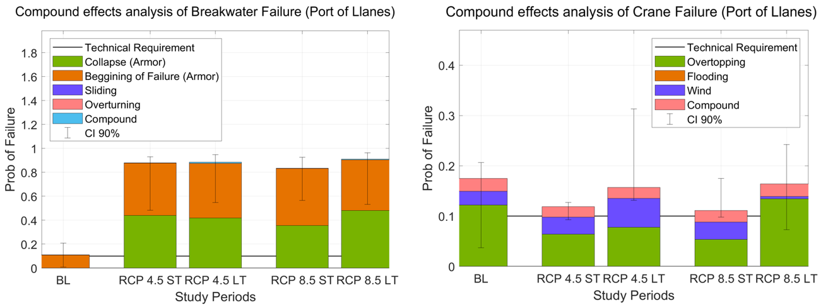
Figure 1 – Compound impact analysis for the study case. On the left, breakwater’s failure modes analyzed. On the right, equipment’s failure modes analyzed
Finally, once main CC-induced impacts have been identified, adaptation measures are proposed to maintain port’s performance above the required levels (hereby, technical codes, ROM 1.0). Therefore, reduction of the probability of armor pieces detachment and overtopping episodes is pursued. To do so, placement of an additional armor layer may diminish both impacts (see Figure 2), analyzed in combination of crown-wall heightening. Optimization of the size of the required units and crown-wall height is performed.
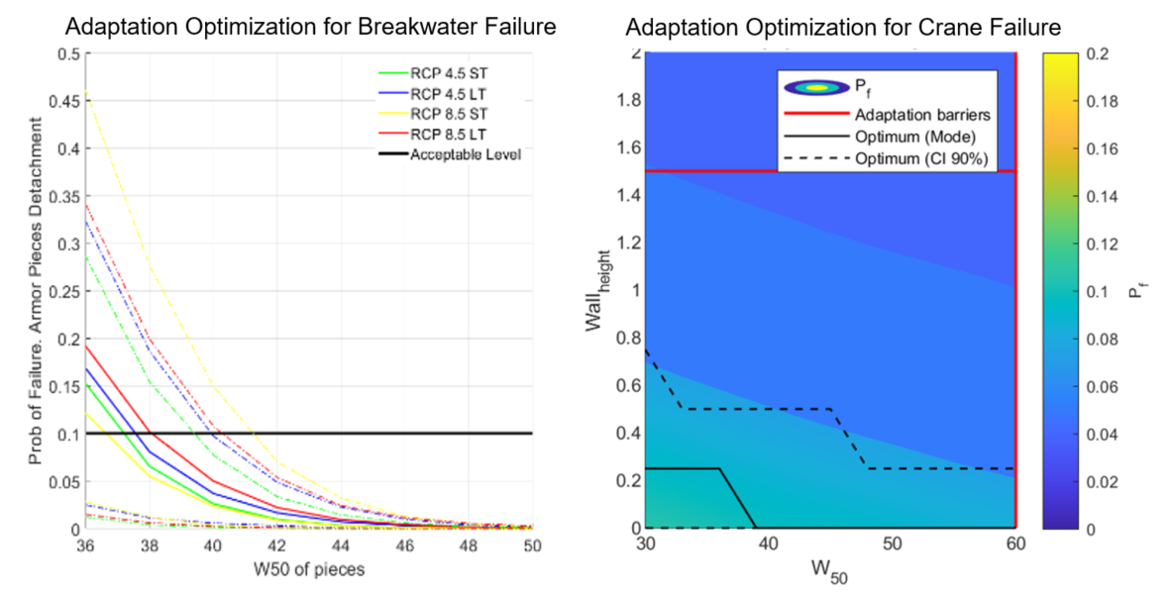
Figure 2 – Adaptation measures for CC optimization. On the left, optimization of breakwater’s units size for breakwater’s failure reduction. On the right, for equipment failure reduction.

ACKNOWLEDGEMENTS
This work has been partially funded under the RETOS program (BIA2017-87213-R) and the State R&D Program Oriented to the Challenges of the Society (PID2020-118285RB-I00) of the Spanish Ministry of Science, Innovation and Universities. The authors are gratefully acknowledged to the Spanish Ministry for the Ecological Transition and the Demographic challenge and the Principado de Asturias for supporting the work.

REFERENCES
Lucio, Tomás, Lara, Losada (2022). Compound extreme and regular nearshore wave climate modeling from high-resolution climate projections for climate change adaptation at the local scale. Coastal Engineering.

