ANISOTROPIC EDDY VISCOSITY
A BENCHMARK CASE STUDY IN AN IDEALISED TIDAL ESTUARY

Annalisa De Leo, University of Genoa, annalisa.deleo@edu.unige.it
Greg Collecutt, BMT, greg.collecutt@bmtglobal.com
Mitchell Smith, BMT, mitchell.Smith@bmtglobal.com
Alessandro Stocchino, CEE - Hong Kong Polytechnic University, alessandro.stocchino@polyu.edu.hk
Bill Syme, BMT, bill.syme@bmtglobal.com

INTRODUCTION
Numerical schemes for solving the full shallow water equations require a turbulence closure model to represent the momentum diffusion caused by turbulence that the velocity fields do not explicitly capture. Typical models include Smagorinsky, depth-U*, Prandlt, and k-epsilon. All of these models predict isotropic eddy viscosity – i.e. the diffusion of momentum acts equally in all directions. However, it is known that when modelling saline transport within an estuary with a 2D scheme, mass dispersion is present in the longitudinal direction due to the depth velocity profile. This is commonly represented in the 2D scheme as an elevated mass diffusion coefficient in the direction of the flow [Lin 1997]. As momentum and heat are both commuted by mass, processes that cause dispersion and diffusion of mass act similarly to disperse/diffuse momentum and heat. It is for this reason that the turbulent Schmidt and Prandlt numbers used in computation fluid dynamics (CFD) are close to unity. This then begs the question: in a 2D numerical scheme, should diffusion of momentum also be applied anisotropically?

In this paper we present a benchmark case study between laboratory measured velocity results and those from numerical simulations using TUFLOW.

LABORATORY TIDAL FLUME
The experiments have been carried out in a large scale tidal flume composed by two main parts: a basin and a tidal compound channel with exponentially decreasing
width landward, divided by a tidal inlet (a sketch of the experimental set-up and the cross section is shown in Figure 1). Different tidal waves were tested varying the tidal period $T$ and amplitude $a$, with the assumption of small amplitude waves. For each experiment, we collected 2D-velocity fields on the free surface using 5 digital cameras, and analysed the acquisitions through the PIV technique. Water level measurements were obtained using ultrasound gauges.
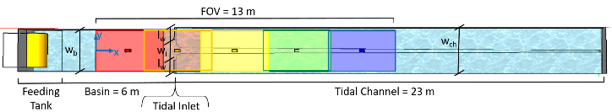Figure 1 – Laboratory Tidal Flume

TUFLOW NUMERICAL SIMULATIONS
A 2D numerical model of the tidal flume was constructed and solved using TUFLOW HPC [Collecutt 2017]. In particular, the software was customized to apply the momentum diffusion anisotropically. An example of the anisotropic momentum diffusion flux calculation is shown in Equation 1 for the u velocity.
$\left[\begin{matrix}∅_{ux} \\ ∅_{uy}\end{matrix}\right]=h∆wRDR^{-1}\left[\begin{matrix}{u'}_{x} \\ {u'}_{y}\end{matrix}\right]$ (1)
where ${u'}_{x}$ and ${u'}_{y}$ are the x and y direction gradients of the u velocity, h is depth, $∆w$ the face width, R the 2D rotation matrix based on the local velocity vector, and D the diffusion matrix:
$R=\left[\begin{matrix}cos\left(θ\right) & -sin\left(θ\right) \\ sin\left(θ\right) & cos\left(θ\right)\end{matrix}\right]$ ; $D=\left[\begin{matrix}D_{l} & 0 \\ 0 & D_{t}\end{matrix}\right]$ (2)
where $D_{l}$ and $D_{t}$ are the longitudinal and transverse diffusion coefficients respectively (which were scaled from the depth-U* eddy-viscosity model), and $θ$ is the flow angle with respect to the x-axis.
The TUFLOW models were forced with a sinusoidal tidal boundary level of the same amplitude and frequency as measured in the laboratory tests.

RESULTS
Velocity and vorticity were compared between the measured and numerical results sets, for time series at selected locations and also 2D maps of tide-cycle ensemble averaged data. An example comparison of ensemble averaged vorticity is shown in Figure 2. Optimal longitudinal and transverse diffusion coefficients are indicated by the results and are presented.

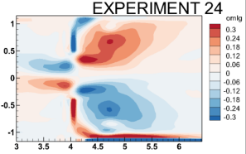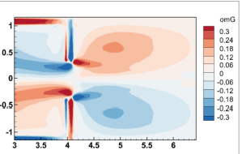
- Test b) Simulation
Figure 2 – Comparison of 2D ensemble averaged vorticity

REFERENCES

Lin, Falconer (1997): Tidal Flow and Transport Modelling Using ULTIMATE QUICKEST Scheme, Journal of Hydraulic Engineering Vol 123 Issue 4
Collecutt, Syme (2017): Experimental Benchmarking of Mesh Size and Time-Step Convergence for a 1st and 2nd Order SWE Finite Volume Scheme, 37th IAHR World Congress.

