48 Annals of Applied Psychophysiology December 2025 Volume 13
_____________________________________________________________________
The Triad of Stress, Vitamin D Deficiency, and Periodontal Breakdown: An Integrative Review Rafique S, Ahmed S, Noushad S, Atif A, Aqeel S, Nasir F
Published online: December 2025
© The Author(s)
Abstract
Background: Recent studies have highlighted a significant link between psychological disorders and oral inflammatory diseases. Emotional disorders such as anxiety and depression can interfere with normal body functions by disturbing the neuro-immune-endocrine axis.
Methodology: This mini-review highlights the importance of integrated approaches in dental and mental health care by integrating research that links oral and psychological domains.
Results: These alterations trigger the onset and progression of periodontitis, a chronic inflammatory disease that harms the tissues supporting the teeth. Vitamin D, especially its active form, 1,25-dihydroxyvitamin D₃, has recently been considered as a vital hormone in protecting mental and periodontal health.
Conclusion: Saliva provides a noninvasive means for assessing physiological markers such as alpha-amylase (sAA), cortisol, interleukin-6 (IL-6), and Chromogranin-A (Cg-A). These biomarkers can offer insight into bodily changes associated with oral inflammation and psychological stress.
Keywords: Monosodium Glutamate (MSG), Dietary Glutamate, Depressive-like Phenotypes, Monosodium Glutamate Induced Depression, Neurotoxicity, animal Models, Supraphysiological Doses.

Corresponding Author
Dr. Sara Rafique, MPhil, PhD scholar
Associate Professor, Department of Physiology,
Jinnah Medical & Dental College, Sohail University,
Shaheed-e-Millat Road, Karachi, Pakistan
Ph: 93345386644 E
mail: sararafique@jmc.edu.pk

Introduction
The link between mental health and systemic inflammatory diseases has gained significant attention, as the prevalence of anxiety and depression is increasing worldwide [1]. Mental health disorders are increasingly recognized not merely as cognitive or emotional disorders, but as conditions affecting the oral health domain. The detrimental effects on periodontal tissues have become a focus of growing attention [2, 3]. Periodontitis is an ongoing inflammatory infection affecting the supporting structures of the teeth [3]. The body's stress response serves as an amalgamating link between oral and mental health. Chronic stress can lead to the over-stimulation of the hypothalamic-pituitary-adrenal (HPA) axis and the sympathetic nervous system (SNS).This results in elevated cortisol levels. The continuously raised cortisol levels can disrupt the balance of the immune response, shifting it towards a more destructive inflammatory state. This inflammatory state contributes to systemic and oral health issues [4].
Vitamin D, a steroid hormone, is not only a bone-regulating vitamin, but is also involved in the regulation of mood. Deficiency in vitamin D has been linked to a higher risk of oral inflammatory diseases, such as periodontitis [5, 6].
This study examines the pathophysiology of vitamin D together with other stress-associated salivary markers to further clarify how these biomarkers, via interconnected pathways, affect both oral health and emotional well-being.
Anxiety and Depression: Biological Mechanisms Related to Oral Health
Anxiety and depression arise from a combination of physiological, psychological, and environmental factors. Each of these factors can contribute to ongoing stress, which in turn overactivates the hypothalamic-pituitary-adrenal (HPA) axis. The HPA axis normally maintains physiological homeostasis during stress. However, when its activation is prolonged, cortisol secretion remains elevated. While short-term cortisol elevation shifts the immune system towards an anti-inflammatory state, its chronically heightened levels can suppress immune responses and promote both systemic and neural inflammation [3, 7].
Neuroinflammation-induced alterations in cortisol levels can lead to decreased concentrations of emotion-regulating neurotransmitters, mainly through their increased reuptake by presynaptic terminals [8, 9]. Inflammatory cytokines stimulate a specific enzyme that converts tryptophan into kynurenine, a neurotoxic metabolite. This neurotoxin activates glutamatergic pathways, promoting excitotoxic damage and reducing levels of brain-derived neurotrophic factor (BDNF). These neurobiological changes heighten vulnerability to anxiety and cognitive deficits, the clinical signs commonly observed in anxiety and depressive disorders [9].
In addition, individuals suffering from anxiety and depression may also experience adverse oral health outcomes. These individuals experience persistent fatigue, decreased motivation, and neglect of self-care routines. These symptoms may result in less frequent tooth brushing and flossing, missed dental check-ups, or the emergence of harmful oral habits such as teeth grinding, tobacco use, or increased consumption of sugary foods.
These habits encourage the accumulation of dental plaque, leading to gingival inflammation, which progresses to periodontitis [10].
Dysregulation of the immune system forms a causal link between psychiatric conditions and periodontal pathology [11]. Multiple investigations reveal that depressive states are characterized by increased production of pro-inflammatory cytokines by the central microglia. The chemokine monocyte chemoattractant protein-1 (MCP-1) is pivotal in directing monocyte migration to emotional brain regions. These include the amygdala and hippocampus—structures that are fundamental to the processing of fear and the encoding of emotional memories [12].

Periodontitis: Immune Imbalance and the Impact of Stress
Periodontitis is a chronic inflammatory ailment predominantly caused by plaque accumulation, which modifies the composition of the oral microflora to incline towards a more virulent Gram-negative species. This provokes the host’s immune response. In the initial phase, the buildup of plaque attracts neutrophils to the affected site, resulting in the formation of an early lesion. If inflammation persists, adaptive T and B lymphocytes migrate into the periodontal tissues. These cells release cytokines that contribute to the connective tissue breakdown and resorption of alveolar bone [13].
A recent study has shown that psychological stress plays a significant role in the progression of periodontal disease [14]. Elevated cortisol levels associated with stress can impair neutrophil chemotaxis, macrophage activity, and natural killer cell responses. These immune alterations reduce the body’s ability to defend against pathogenic bacteria, enabling periodontal microorganisms like Porphyromonas gingivalis to proliferate.
In addition, chronic stress increases the production of pro-inflammatory cytokines, including Interleukin-6 (IL-6) and tumor necrosis factor-alpha (TNF-α). These cytokines are involved in the degradation of periodontal tissues [3].
Activation of the sympathetic nervous system under stressful conditions has significant consequences on periodontal health [15, 16]. Increased autonomic activity is indicated by higher concentrations of salivary alpha-amylase and Chromogranin-A. Both are acknowledged as markers of sympathetic stimulation. These biomarkers lead to reduced saliva and alterations in its composition, creating the conditions that encourage the proliferation of pathogenic microorganisms [16, 17].
Clinical observations often reveal that individuals subjected to prolonged psychological stress have an increased risk of developing periodontitis. These individuals commonly exhibit more severe clinical signs of periodontitis [18].
The interaction between physiological mechanisms and behavioral patterns connecting stress with periodontal disease emphasizes the importance of addressing mental health within the framework of comprehensive periodontal management.
Vitamin D as a Biological Connection between Mental Well-Being and Oral Health
Vitamin D’s role has been established as an essential hormone for calcium regulation and bone health. More recently, its role in modulating immune responses and influencing neuroprotection has been acknowledged [19]. The active form, 1,25-dihydroxyvitamin D₃, exerts its effects by binding to vitamin D receptors. These receptors are found not only in conventional target tissues but also in immune cells, limbic areas of the brain, and periodontal tissues [20, 21].
Vitamin D is vital in maintaining periodontal health by regulating inflammatory processes. It reduces pro-inflammatory cytokines, such as interleukin-6 and tumor necrosis factor-alpha. This essential vitamin supports the synthesis of anti-inflammatory mediators. In addition, the active vitamin D increases the production of cathelicidin, an antimicrobial peptide that protects against periodontal pathogens. By regulating bone remodeling, vitamin D contributes to bone formation and limits bone loss. These processes help to maintain alveolar bone integrity and slow the progression of periodontal disease [21].
Studies have reported a negative correlation between vitamin D levels and the severity of periodontal disease. This suggests that insufficient vitamin D may be associated with severe periodontal tissue breakdown [22, 23].
There is strong evidence linking vitamin D status to mental health. Key brain regions involved in emotional regulation, such as the hippocampus, amygdala, and prefrontal cortex, have receptors for vitamin D and the enzyme responsible for converting vitamin D to its active form.
Vitamin D increases the expression of tryptophan hydroxylase-2, the enzyme necessary for serotonin synthesis, a neurotransmitter that plays a central role in mood regulation. As serotonin is important for emotional regulation, cognitive function, and mood stability, inadequate levels of vitamin D can reduce serotonin production and increase the risk of developing anxiety and depressive symptoms [24].
Vitamin D plays an important role in safeguarding neural tissue by improving mitochondrial integrity and reducing oxidative stress. It stimulates antioxidants, such as glutathione, which serve to reduce the buildup of reactive oxygen species in brain tissue. Deficiency in vitamin D can result in degeneration of GABAergic neurons. This disruption disturbs the equilibrium between excitatory and inhibitory neurotransmitters, leading to a hyperactive amygdala. Therefore, low vitamin D status may contribute to psychological health issues and periodontal integrity issues [24].
Addressing vitamin D deficiency may offer therapeutic advantages in both mental health and oral health areas.
Stress-sensitive Salivary Biomarkers Connecting Oral and Mental Health
Saliva is a biological fluid composed of hormones, cytokines, enzymes, and peptides. These molecules enter saliva through both transcellular and paracellular transport processes. This results in a molecular composition that reflects the state of both oral and systemic health.
Saliva provides a non-invasive medium for studying the interplay between stress-related physiological changes and oral health conditions. Its correlation with serum biomarkers strengthens its utility in evaluating psychological and dental health [25, 26]. This underscores the growing recognition of saliva as a valuable diagnostic tool for investigating the relationship between psychological factors and oral health.
Cortisol remains one of the most extensively studied salivary biomarkers. This steroid hormone is recognized as a reliable indicator of hypothalamic-pituitary-adrenal (HPA) axis activity. Individuals experiencing stress frequently exhibit increased concentrations of salivary cortisol [14]. Although cortisol plays a protective role during episodes of acute stress, its persistently elevated levels contribute to systemic inflammation and a compromised local immune response. Elevated salivary cortisol is associated with increased periodontal pocket depth, worsened gingival inflammation, and reduced resistance to oral infections [14, 27].
Interleukin-6 (IL-6) is an important inflammatory marker that links behavioral conditions with oral disorders. This cytokine plays a central role in immune system regulation, and its levels increase in response to both emotional stress and periodontal inflammation. Elevated salivary IL-6 is associated with greater osteoclastic activity, connective tissue breakdown, and increased inflammatory cell infiltration in periodontal tissues [28]. It influences behavior by promoting neuroinflammation, thereby increasing an individual’s susceptibility to anxiety and depression [29].
The sympathetic nervous system's activity can be assessed non-invasively through salivary alpha-amylase [30]. This protein alters saliva composition and oral immunity, impairs antibacterial defenses, and heightens the likelihood of periodontal infections [17].
Chromogranin-A (Cg-A) is another important autonomic marker. As a glycoprotein, it reflects changes in the autonomic nervous system and is sensitive to psychological stress [16]. Cg-A is a precursor to several peptides involved in immune regulation and periodontal inflammation [31].
Elevated concentrations of cortisol, Chromogranin A (Cg-A), and alpha-amylase in saliva are widely recognized as markers of heightened hypothalamic-pituitary-adrenal (HPA) axis and sympathetic nervous system activity. In parallel, increased levels of interleukin-6 (IL-6) reflect inflammatory responses that often accompany both psychological stress and oral inflammatory diseases.

Conclusion
The intricate relationship between anxiety, depression, and periodontitis underscores the necessity of viewing oral and mental health as interconnected, rather than isolated domains. Psychological stress exerts influence on neuroendocrine regulation, immune system function, and behavioral patterns, each of which heightens vulnerability to periodontal disease.
Vitamin D plays a pivotal role in modulating these biological pathways, thereby impacting emotional well-being and the integrity of periodontal tissues.
Salivary biomarkers provide a valuable, non-invasive window into these complex mechanisms. This medium allows clinicians to assess underlying physiological changes noninvasively before visible symptoms appear, facilitating earlier intervention.
Recognizing these shared mechanisms advocates an integrated health care approach- one that bridges mental and oral health strategies for prevention, early detection, and effective treatment. This proactive approach not only holds promise for improving patient outcomes but also has the potential to alleviate long-term healthcare costs and resource burdens associated with advanced disease states.

Figure 1. Reduced salivary 1,25(OH)₂D₃ and elevated levels of cortisol, IL-6, Cg-A, and sAA disrupt neuro-endocrine–immune homeostasis, promote hyperactivity of the HPA axis and sympathetic nervous system, and shift immunity towards a destructive phase, thereby increasing vulnerability to anxiety, depression, and periodontitis.

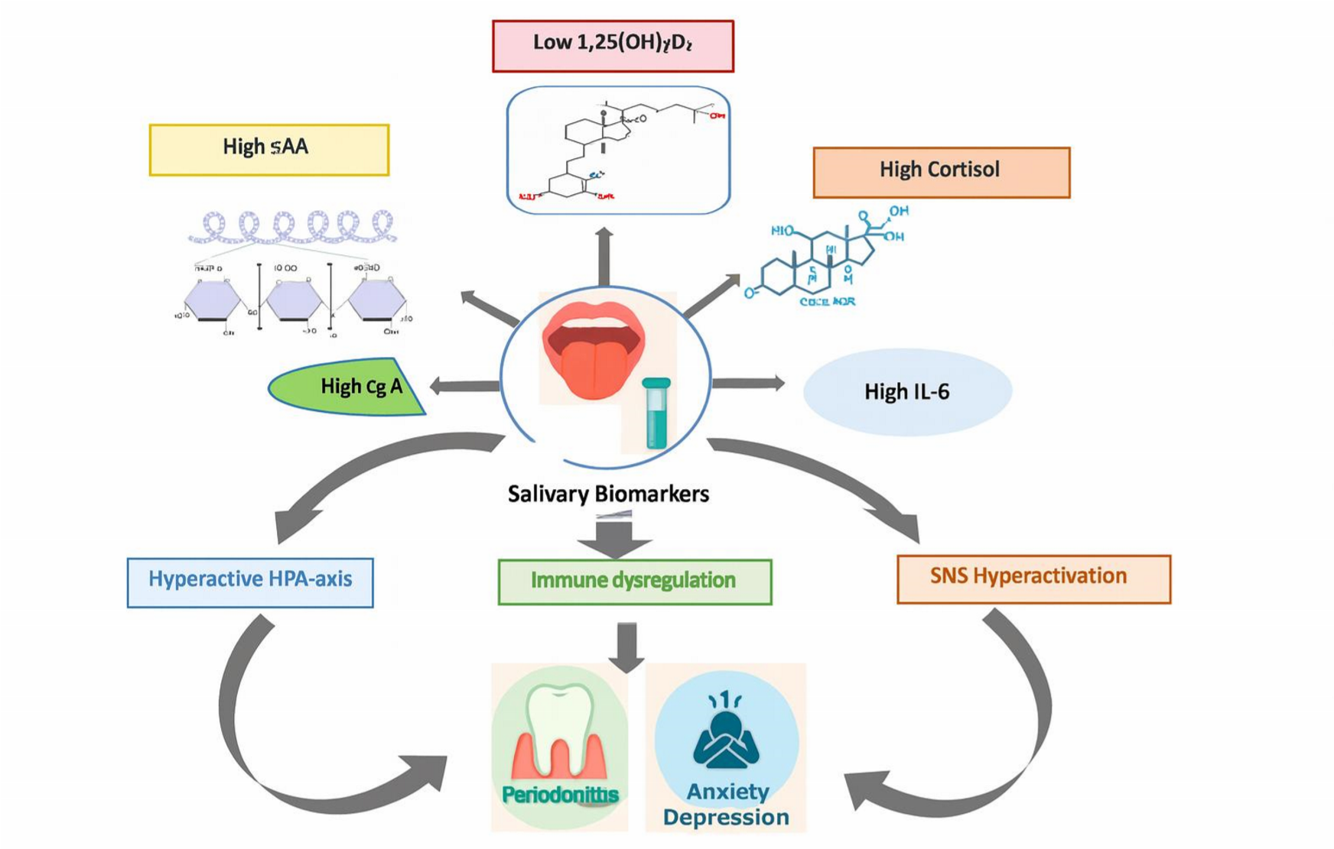

References
Ali M, Taj Y, Tanwir F, et al. MMP-8, IL-6, IL-1β as biomarkers. Age. 2025;15:39-
5.10.29271/jcpsp.2025.07.825

Ali N, Nater UM. Salivary alpha-amylase as a stress biomarker. Int J Behav Med. 2020;27(3):337-42.10.1007/s12529-019-09843-x.

Al Shaar A, Hamadeh O, Ali A. Saliva and serum biomarkers. Medicine. 2024;103(52):e41072.10.1097/MD.0000000000041072.

Antonoglou GN, et al. Low serum 1,25(OH)2D and periodontitis. J Periodontal Res. 2015;50:274-80.

Ball J, Darby I. Mental health and periodontal and peri-implant diseases. Periodontol
2000. 2022;90(1):106-24.10.1111/prd.12452

Becerra-Ruiz JS, Guerrero-Velázquez C, Martínez-Esquivias F, et al. Innate and adaptive immunity… Oral Dis. 2022;28(6):1441-7.10.1111/odi.13884

Charoenngam N, Shirvani A, Holick MF. Vitamin D for skeletal and non-skeletal health. J Clin Orthop Trauma. 2019;10(6):1082-93.10.1016/j.jcot.2019.07.004.

Chung C, Silwal P, Kim I, Modlin RL, Jo EK. Vitamin D-cathelicidin axis… Immune
Netw. 2020;20(2):e12. 10.4110/in.2020.20.e12

Develioglu H, Korkmaz S, Dundar S, Schlagenhauf U. Salivary markers in periodontitis. J Oral Biol Craniofac Res. 2020;10(4):514-8.10.1016/j.jobcr.2020.07.020.

Gkolfinopoulos S, Tsapakidis K, Papadimitriou K, et al. Chromogranin A as a marker.
World J Methodol. 2017;7(1):9.10.5662/wjm.v7.i1.9

Gunepin M, Derache F, Trousselard M, et al. Chronic stress and periodontal health. J
Oral Med Oral Surg. 2018;24(1):44-50.10.1051/mbcb/2017028

Hassamal S. Chronic stress, neuroinflammation, and depression… Front Psychiatry.
2023;14:1130989.https://doi.org/10.3389/fpsyt.2023.1130989

Hashim NT, Fathima S, Hisham NM, et al. Salivary alpha-amylase in periodontitis. Curr Issues Mol Biol. 2024;46(11):12230-43.10.3390/cimb46110726.

Hingorjo MR, Owais M, Siddiqui S, et al. Stress and salivary cortisol in periodontitis. BMC Oral Health. 2025;25:276.10.1186/s12903-024-05017-8.

Hoffmann K, Emons B, Brunnhuber S, et al. Dietary supplements in depression.
Pharmacopsychiatry. 2019;52(6):261-79.10.1055/a-0942-1875.

Küchler EC, Schröder A, Teodoro VB, et al. Vitamin D receptor in periodontal ligament cells. BMC Oral Health. 2021;21:386.https://doi.org/10.1186/s12903-02101740-8

Liu K, Meng H, Hou J. Vitamin D function in gingival fibroblasts. PLoS One. 2012;7(6):e39878.

Mirzaei M, Ardekani SM, Mirzaei M, Dehghani A. Prevalence of depression, anxiety and stress among adult population: results of Yazd health study. Iran J Psychiatry.
2019;14(2):137.

Malek R, Gharibi A, Khlil N, Kissa J. Necrotizing ulcerative gingivitis. Contemp Clin Dent. 2017;8(3):496-500.10.4103/ccd.ccd_1181_16

Miller AH. Inflammation and depression. Psychiatric Times. 2018;35(4).

NIH Office of Dietary Supplements. Vitamin D Fact Sheet for Health Professionals. 2017.

O’Donovan A, Hughes BM, Slavich GM, et al. Anxiety, cortisol and IL-6. Brain
Behav Immun. 2010;24(7):1074-7.10.1016/j.bbi.2010.03.003

Proma MA, Daria S, Nahar Z, et al. MCP-1 in major depressive disorder. J Basic Clin Physiol Pharmacol. 2022;33(6):735-41.10.1515/jbcpp-2021-0132.

Rafique S, Khan S, Ahmed S, et al. Vitamin D binding protein in periodontitis. Pak J Med Sci. 2019;35(3):847.https://doi.org/10.12669/pjms.35.3.482

Rafique S, Ahmed S, Noushad S. Salivary vitamin D & cortisol… Steroids. 2025:109674.10.1016/j.steroids.2025.109674.

Santos SV, Silva LA, Terra FD, et al. Salivary alpha-amylase and stress. Rev Lat Am Enfermagem. 2021;29:e3468.10.1590/1518-8345.4859.3468.

Soysal F, Isler SC, Guney Z, et al. Salivary chromogranin A and periodontal health.
BMC Oral Health. 2025;25:1536.https://doi.org/10.1186/s12903-025-06912-4

Tang Q, Xu W, Zhang F, et al. Interdisciplinary research on periodontitis and depression. Front Oral Health. 2025;6:1588737.https://doi.org/10.3389/froh.2025.1588737

Walther C, Lieske B, Borof K, et al. Periodontitis and depression… Brain Behav Immun. 2023;34:100689.10.1016/j.bbih.2023.100689.

Yaribeygi H, Panahi Y, Sahraei H, Johnston TP, Sahebkar A. The impact of stress on body function: A review. EXCLI J. 2017;16:1057. 10.17179/excli2017-480

Zhang J, Lin S, Luo L, et al. Psychological stress: neuroimmune roles in periodontal disease. Odontology. 2023;111(3):554-64.10.1007/s10266-022-00768-8.

