25 Annals of Applied Psychophysiology December 2024 Volume 11
______________________________________________________________________________
Establishment of the Relationship Between Continued Practice of Hatha Yoga and Goal Attainment
Amé Foster¹,
Published online: December 2024
© The Author(s) 2

Abstract

Background: This original dissertation research explored the understanding as to why novice yoga students terminate participation. This research is important due to the fact that there is limited information and data available within this specific subject matter of yoga practice.

Methodology: The relationship between continued yoga practice and goal attainment was examined through goal achievement, in addition to psychological inventories and assessments. The research was conducted among eighteen novice yoga participants both male and female.

Results: The main results of the research study quantified the influences of the Hatha yoga intervention calculated through pre-post change scores in the psychological assessments. The outcomes revealed a strong inverse relationship between negative affect and relaxation state; and a moderate inverse relationship between positive affect and relaxation state for the non-drop-out subjects, which included six individuals. Furthermore, the subject goal information established that the type of goals varied between the drop-out and non-drop-out participants.

Conclusion: The results of this research denote that individuals who develop goals more focused on mood enhancement and relaxation improvement as well as establishing a sense of community tend to continue yoga practice and attend classes in comparison to subjects with goals focused specifically related to only addressing health concerns.

Keywords: Yoga, goal attainment, relaxation, mood and affect, drop-out

- Amé Foster afoster1@saybrook.edu
Saybrook University, Pasadena, CA USA

Introduction
Previous research conducted on Hatha yoga demonstrates that it is indeed a successful psychophysiological intervention. However, the limited amount of data observing the reasoning behind yoga practice cessation is significantly lacking.
This research assessed the relationship between continued yoga practice and goal attainment examined through goal achievement, in addition to examinations of psychological inventories and assessments. This was completed with measurements before and after the intervention period.
The assessments included Goal Attainment Scaling, the Positive and Negative Affect Scale, the Profile of Mood States Questionnaire, and the RMM (e) Inventory. The objective was to expand the knowledge currently understood between the relationship of yoga attendance and goal achievement as well as psychological and physical changes within the subjects.

Methodology
Research Method
The information was acquired through a pre-post design model. The subjects included yoga students from two yoga studios in the state of Kansas. The participant inclusion conditions consisted of the following: (a) Subject candidates are at least 18 years of age, (b) Subject candidates are available to participate in an approximately 1-hour yoga session one to two times a week for two months, and (c) Subject candidates are beginners at the practice of yoga.
The exclusion conditions contained the following: (a) Subject candidates do experience symptoms of a mental health disorder and are not currently seeking treatment by a professional, (b) Subject candidates are not 18 years or older, (c) Subject candidates are not available to participate in an approximately 1-hour yoga session one to two times a week for two months, (d) Subject candidates have previously practiced yoga, and (e) Subject candidates attend a different type of yoga class other than hatha yoga during participation in the study.
Involvement in this study was for a period of two months for a minimum of eight yoga classes. The total subject number was eighteen.
Measures
Each participant provided information for the pre-participation survey. Correspondingly, a goal attainment scale, the positive and negative affect scale, the profile of mood states questionnaire, and the RMM-e tracker inventory were all completed before and after the two-month intervention period. Finally, the attendance of each participant was recorded.
This research utilized a quantitative method data analysis approach. The quantitative data analyses included descriptive statistics, the Wilcoxon signed rank test, and linear regression and correlation analysis of the psychometric measurements. The significance levels within each appropriate analysis were measured utilizing the value of equal or less than (p ≤0.05) with a 95% confidence level.
Subject Information
Subjects included males and females all over the age of eighteen years. Each participant was categorized as a beginning level yoga student with no prior yoga practice experience. Subjects were gathered from two yoga studios in a rural Kansas area. Supplementary subject details included medications and treatments. Specifically mental health therapy for three individuals and an SSRI medication for one subject.

Results
The examination of the psychological elements was achieved through the analysis of pre and post change scores. These analyses were completed applying a linear regression and correlation analysis with a p-value (<0.05) among the data from non-dropout participants. The results revealed a moderate inverse relationship between positive affect and state relaxation, and a strong inverse relationship between negative affect and the state of relaxation.

Table 1: Positive Affect Descriptive Statistics
Positive Affect
Group | N | Mean | SD | SE | Median |  | Minimum | Maximum
Total Participants (Pre) | 10 | 37.2 | 9.508 | 3.007 | 40 |  | 22 | 49
Total Participants (Post) | 10 | 36 | 9.201 | 2.91 | 38 | 18 |  | 46
Non-Dropout (Pre) | 6 | 42.83 | 4.355 | 1.778 | 43 | 38 |  | 49
Non-Dropout (Post) | 6 | 38 | 8.602 | 3.512 | 38.5 | 22 |  | 46

Table 2: Negative Affect Descriptive Statistics
Negative Affect
Group | N | Mean | SD | SE | Median |  | Minimum | Maximum
Total Participants (Pre) | 10 | 12.6 | 4.169 | 1.318 | 11 |  | 8 | 21
Total Participants (Post) | 10 | 13.8 | 5.287 | 1.672 | 11.5 | 9 |  | 24
Non-Dropout (Pre) | 6 | 13.17 | 4.355 | 1.778 | 12.5 | 9 |  | 21
Non-Dropout (Post) | 6 | 12.17 | 4.446 | 1.815 | 10.5 | 9 |  | 21

Table 3: Relaxation Mediation Mindfulness Inventory Descriptive Statistics
RMM
Group | N | Mean | SD | SE | Median | Minimum | Maximum
Total Participants (Pre) | 10 | 2.98 | 0.5029 | 0.159 | 2.7 | 2.6 | 3.8
Total Participants (Post) | 10 | 3.26 | 0.6603 | 0.2088 | 3.4 | 1.8 | 4
Non-Dropout (Pre) | 6 | 3.167 | 0.5175 | 0.2333 | 3.1 | 2.6 | 3.8
Non-Dropout (Post) | 6 | 3.467 | 0.4131 | 0.1687 | 3.4 | 2.8 | 4

Table 4: Profile of Mood States Descriptive Statistics
Profile of Mood States
Group | N | Mean | SD | SE | Median | Minimum | Maximum
Total Participants (Pre) | 5 | 13 | 26.95 | 12.05 | 14 | -27 | 49
Total Participants (Post) | 5 | 6.4 | 27.63 | 12.36 | 3 | -26 | 50
Non-Dropout (Pre) | 4 | 4 | 20.704 | 10.35 | 13.5 | -27 | 16
Non-Dropout (Post) | 4 | -8.5 | 12.503 | 6.251 | -5.5 | -26 | 3

Table 5

Goal Attainment Scale Results
Participant Attainment Level ______________________________________________________________________________
(Non-DO)
Pre-Intervention Goals Improve Flexibility 1 Greater than Expected
Enhance relaxation
Improve shoulder mobility

Post-Intervention Goals Improve flexibility
Enhance relaxation
Improve shoulder mobility
Become more Fit
______________________________________________________________________________
(Non-DO)
Pre-Intervention Goals Community 2 Expected
Keep of recent weight loss
Improve mobility

Post-Intervention Goals Community
Keep of recent weight loss
Improve overall health
Reduce stress level
______________________________________________________________________________
(Non-DO)
Pre-Intervention Goals Flexibility 3 Not Selected
Improve upper body strength
Improve core muscles
Improve mindfulness

Post-Intervention Goals Flexibility
Improve upper body strength
Improve core muscles
Improve mindfulness
______________________________________________________________________________
(Non-DO)
Pre-Intervention Goals Community 4 Greater than Expected
Improve flexibility
Improve mindfulness
Improve emotional stability
Post-Intervention Goals Increase a sense of Community
Increase physical activity
Improve flexibility
Enhance relaxation and calm
______________________________________________________________________________
(DO)
Pre-Intervention Goals Body appreciation 5 Not Selected
Better sleep and stress relief
Improve flexibility
Injury Prevention

Post-Intervention Goals No Data
(DO)
Pre-Intervention Goals No Data 6 Not Selected

Post-Intervention Goals No Data
(DO)
Pre-Intervention Goals Self-improvement and self-care 7 Not Selected
Improve range of motion
Success in college and Clarity
Marathon preparation

Post-Intervention Goals No Data
(DO)
Pre-Intervention Goals Attend yoga twice per week 8 Not Selected
Move body everyday
Book 5 photo shoots
Become a Yoga Instructor

Post-Intervention Goals No Data
(Non-DO)

Pre-Intervention Goals More active 9 Greater than Expected
Enhance relaxation and peace
Improve muscle tone
Become a Yoga Instructor

Post-Intervention Goals Self-awareness
Muscle tone
(Non-DO)
Pre-Intervention Goals More active 10 Greater than Expected
Improve breathing
Improve motivation

Post-Intervention Goals More active
Improve breathing
Improve motivation

(DO)
Pre-Intervention Goals Stay in movement 11 Not Selected
Improve flexibility

Post-Intervention Goals No Data
(DO)
Pre-Intervention Goals Improve breathing 12 Not Selected
Improve flexibility

Post-Intervention Goals No Data
(DO)
Pre-Intervention Goals Relaxation 13 Not Selected
Muscle tone
Weight loss

Post-Intervention Goals Relaxation
Muscle tone
Weight loss
______________________________________________________________________________
(DO)
Pre-Intervention Goals Relaxation 14 Not Selected
Improve teaching lessons
Relax muscles

Post-Intervention Goals Relaxation
Improve teaching lessons
Relax muscles
______________________________________________________________________________
(DO)
Pre-Intervention Goals Enhance mood 15 Not Selected
Improve flexibility
Increase core strength
Relaxation and focus on breathing

Post-Intervention Goals Enhance mood
Improve flexibility
Increase core strength
Relaxation and focus on breathing
______________________________________________________________________________
(DO)
Pre-Intervention Goals Improve balance 16 Not Selected
Improve flexibility
Stay calm and balanced
Relaxation and positive mood

Post-Intervention Goals Delay aging
Maintain health and flexibility
Increase mental health and focus
Relaxation and positive mood
(DO)
Pre-Intervention Goals Improve balance 17 Not Selected
Improve flexibility
Stay calm and balanced

Post-Intervention Goals No Data
(DO)
Pre-Intervention Goals Improve balance 18 Not Selected
Improve flexibility
More strength
Decrease stress and improve breathing

Post-Intervention Goals No Data

Note. Participants determined and recorded individual goals for attending and practicing yoga on a goal attainment scale. Additionally, the goal attainment level was reported in the post-intervention GAS results. The results which state Not Selected or No Data for the attainment level and goal content are due to incomplete outcomes reported by the subjects who dropped out. The dropout status is indicated in parentheses above the participant number. Non-DO represents non-dropout and DO represents dropout.
The attainment levels are measured to determine if the participant has met their individualized goals and expectations for the yoga practice.

Figure 1
Positive Affect and Relaxation State Pre-Post Change Scores Correlation

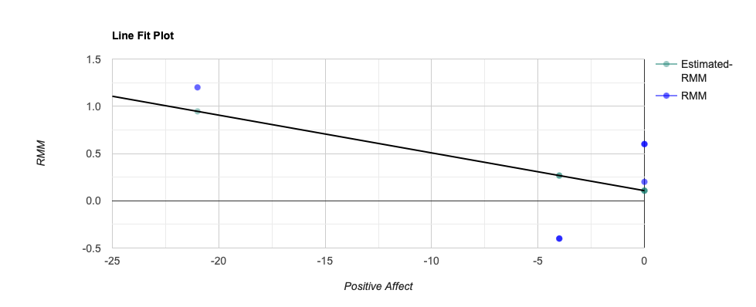

Note. The data as gathered from the pre-post change scores of the positive affect (PA) and the Relaxation Meditation and Mindfulness (RMM) Inventory results of non-dropout participants to calculate a linear regression and correlation analysis. This analysis examined the relationship between the two variables with the aim to establish the connection among the fluctuations within the psychological measurement outcomes. Specifically, for the subjects that maintained extended yoga class attendance.
R² = .27, F(1,4) = 1.47, p = .292. β = -.04, p = .292. R-Squared (R²) equals 0.2684. Meaning that 26.8% of the variability of Relaxation is explained by Positive Affect. Correlation (R) equals -0.5181. Denoting that there is a moderate inverse relationship between Positive Affect and Relaxation. This is considered a paradoxical finding.

Figure 2
Negative Affect and Relaxation State Pre-Post Change Scores Correlation

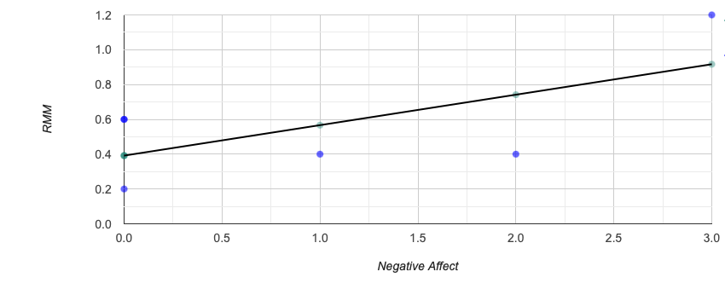
Note. The data as gathered from the pre-post change scores of the Negative Affect (NA) and the Relaxation Meditation and Mindfulness (RMM) Inventory results of non-dropout participants to calculate a linear regression and correlation analysis. This analysis examined the relationship between the two variables with the aim to establish the connection among the fluctuations within the psychological measurement outcomes. Specifically, for the subjects that maintained extended yoga class attendance.
R² = .41, F(1,4) = 2.81, p = .169. β = .18, p = .169. R-Squared (R²) equals 0.4129. This means that 41.3% of the variability of increased Relaxation is explained by Negative Affect reduction. Correlation (R) equals 0.6426, denoting that there is a strong inverse relationship between Negative Affect and Relaxation.

Figure 3
Positive Affect and POMS Pre-Post Change Scores Correlation

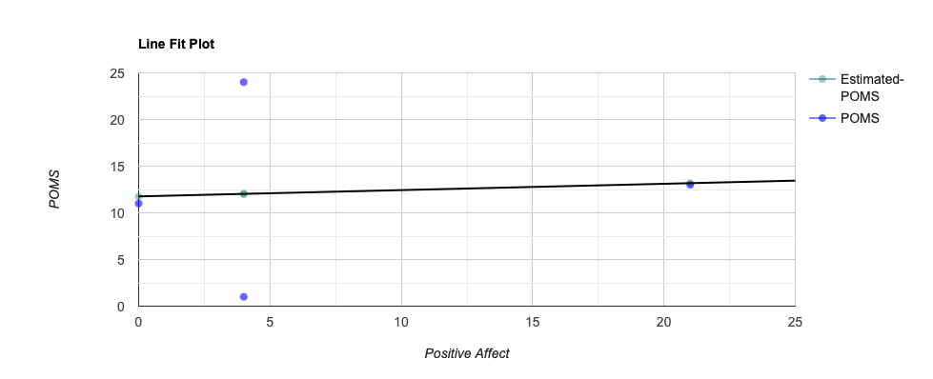

Note. The data as gathered from the pre-post change scores of the Positive Affect (PA) and the Profile of Mood States (POMS) results of non-dropout participants to calculate a linear regression and correlation analysis. This analysis examined the relationship between the two variables with the aim to establish the connection among the fluctuations within the psychological measurement outcomes. Specifically, for the subjects that maintained extended yoga class attendance.
R² = .0045, F(1,2) = 0.009, p = .933. β = .068, p = .933. R-Squared (R²) equals 0.004495. This means that 0.4% of the variability of POMS is explained by Positive Affect. Correlation (R) equals 0.06705, denoting that there is a very weak direct relationship between Positive Affect and POMS. This is considered a paradoxical finding.

Figure 4
Negative Affect and POMS Pre-Post Change Scores Correlation
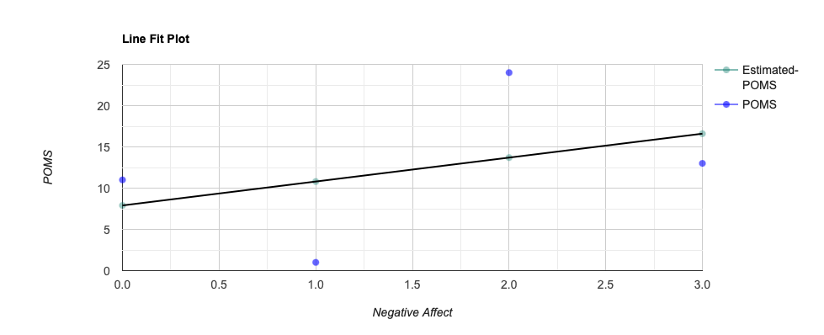
Note. The data as gathered from the pre-post change scores of the Negative Affect (NA) and the Profile of Mood States (POMS) results of non-dropout participants to calculate a linear regression and correlation analysis. This analysis examined the relationship between the two variables with the aim to establish the connection among the fluctuations within the psychological measurement outcomes. Specifically, for the subjects that maintained extended yoga class attendance.
R² = .16, F(1,2) = 0.37, p = .603. β = 2.9, p = .603. R-Squared (R²) equals 0.1576. This means that 15.8% of the variability of POMS is explained by Negative Affect. Correlation (R) equals 0.397, denoting that there is a weak direct relationship between Negative Affect and POMS.

Figure 5
Relaxation State and POMS Pre-Post Change Scores Correlation

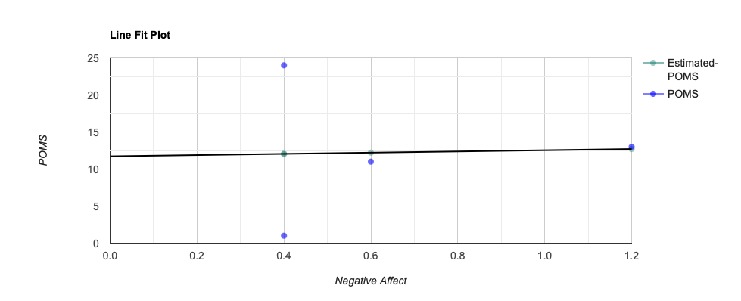
RMM

Note. The data as gathered from the pre-post change scores of the Relaxation Meditation and Mindfulness (RMM) Inventory and the Profile of Mood States (POMS) results of non-dropout participants to calculate a linear regression and correlation analysis. This analysis examined the relationship between the two variables with the aim to establish the connection among the fluctuations within the psychological measurement outcomes. Specifically, for the subjects that maintained extended yoga class attendance.
R² = .0011, F(1,2) = 0.0021, p = .967. β = .81, p = .967. R-Squared (R²) equals 0.001068, meaning that 0.1% of the variability of POMS is explained by RMM. Correlation (R) equals 0.03268, and denoting that there is a very weak direct relationship between the RMM and POMS.

Discussion
Ancillary data was obtained regarding attendance and dropout rates. This information includes the narratives of four out of the eighteen subjects in the study that dropped out. These subjects replied to the investigator during the post-research data collection. Each subject claimed that attendance cessation occurred due to non-availability.
The total dropout percentage was 66.6%. There was an important correlation between attendance and the goal content among the subjects who maintained attendance. The goal attainment scaling content results demonstrate that the goal content is significant and presents a connection between the participants who completed the intervention period and continued to practice yoga in contrast to those participants who did not. The goals of the non-drop-out subjects who maintained yoga class attendance incorporated goals focused on improved relaxation and mood as well as decreased levels of stress, and the importance of community. Moreover, these subjects completed the goal attainment scaling level detailing that the goals were achieved.
Furthermore, each subject who maintained attendance in the yoga classes demonstrated an increase of relaxation state and a reduction in the total mood disturbance score as well as decrease of negative affect. Nevertheless, the paradoxical findings between the particular change scores are notable due to the opposite nature of the expected outcomes.
Limitations
The main limitation of this research includes the small number of subjects. This was most likely due to a limited sample population in a rural area. The second critical limitation was the high drop-out rate. Finally, incomplete data is available outside of the utilized assessments concerning the individual subject experience of the yoga practice.
Conclusion
The outcomes of this research provide more detailed information behind the reasoning for yoga practice cessation. Existing research provides only minimal explanations regarding this topic and includes results from yoga attendance within medical group research studies and group therapy treatments. The data gathered from these subjects offers evidence to support the preceding research for group therapy treatments, in conjunction with contributing more understanding within the general population of yoga practitioners. Particularly, concerning the influences of attendance and dropout. The practical purposes of this information might help yoga studios more productively focus on the needs of the students attending; and thus, improve retention rates. Additionally, when the necessities of the yoga students are more fully met, the psychological components examined within this research may be improved.
Acknowledgment
The author acknowledges the support of the professors from Saybrook University who participated in the development of this research and dissertation.

References
Ashford, S., Williams, H., Nair, A., Orridge, S., & Turner-Stokes, L. Categorization of goals set
using Goal Attainment Scaling for treatment of leg spasticity: a multicentre analysis. Disability and Rehabilitation. (2019);41(16), 1925–1930.

Barrett, Marna S.; Wee-Jhong, Chua; Crits-Christoph, Paul; Gibbons, Mary Beth; Casiano, D.;
Thompson, Don. (2009). Early Withdrawal from Mental Health Treatment: Implications for Psychotherapy Practice. Psychotherapy (Chic) 45(2), 247-267.

Butterfield, N., Schultz, T., Rasmussen, P., & Proeve, M. Yoga and mindfulness for anxiety and
depression and the role of mental health professionals: A literature review. The Journal of Mental Health Training, Education, and Practice. (2017); 12(1), 44-54.

Chester, H., Beresford, R., Clarkson, P., Entwistle, C., Gillan, V., Hughes, J., Orrell, M., Pitts,
R., Russell, I., Symonds, E., & Challis, D. The Dementia Early Stage Cognitive Aids New Trial (DESCANT) intervention: A goal attainment scaling approach to promote self‐management. International Journal of Geriatric Psychiatry. (2021); 36(5), 784–793.

Cramer, H., Lauche, R., Langhorst, J., & Dobos, G. Yoga for depression: A systematic review
and meta-analysis. Depression and Anxiety. (2013); 30(11), 1068–1083.

Cramer, H., Ward, L., Saper, R., Fishbein, D., Dobos, G., & Lauche, R. (2015). The Safety of Yoga: A Systematic Review and Meta-Analysis of Randomized Controlled Trials. American Journal of Epidemiology, 182(4), 281–293. https://doi.org/10.1093/aje/kwv071

Cramer, H., Haller, H., Dobos, G., & Lauche, R. A systematic review and meta-analysis
estimating the expected dropout rates in randomized controlled trials on yoga interventions. Evidence-Based Complementary and Alternative Medicine. (2016); 5859729–7.

Eda, N., Ito, H., Shimizu, K., Suzuki, S., Lee, E., & Akama, T. Yoga stretching for improving
salivary immune function and mental stress in middle-aged and older adults. Journal of Women & Aging. (2018); 30(3), 227–241.

Kabat-Zinn, J., & Kabat-Zinn, J. Full catastrophe living: Using the wisdom of your body and
mind to face stress, pain, and illness. (2013). Bantam Books.

Kinser, Patricia A.; Goehler, Lisa Elane; Taylor, Anne Gill. How might yoga help depression? A
neurobiological perspective, EXPLORE. (2012); 8(2), 118-126.

Kiresuk, T. J., Stelmachers, Z. T., & Schultz, S. K. Quality assurance and goal attainment
scaling. Professional Psychology. (1982); 13(1), 145–152.

Lee, C. E., Shogren, K. A., Segal, J., Pezzimenti, F., Aleman-Tovar, J., & Taylor, J. L. Goal
attainment scaling: A method to incorporate personalized outcomes into intervention research with youth and adults on the autism spectrum. The International Journal of Research and Practice. (2022); 26(1), 178–187.

Lutz, W., Hofmann, S. G., Rubel, J., Boswell, J. F., Shear, M. K., Gorman, J. M., Woods, S. W.,
Barlow, D. H., & Nezu, A. M. (2014). Patterns of Early Change and Their Relationship to Outcome and Early Treatment Termination in Patients with Panic Disorder. Journal of Consulting and Clinical Psychology, 82(2), 287–297. https://doi.org/10.1037/a0035535

Malia, T. Self-Reports of Relaxation and Mindfulness States among Experienced Practitioners of
Mindfulness Related Disciplines. (2018). ProQuest Dissertations & Theses.

Mayo Clinic. (2022, April 28). Stress Management. Mayo Clinic.
https://www.mayoclinic.org/healthy-lifestyle/stress-management/in-depth/relaxation-technique/art-20045368

Mayo Clinic. (2022, April 29). Meditation: A simple, fast way to reduce stress. Mayo Clinic.
https://www.mayoclinic.org/tests-procedures/meditation/in-depth/meditation/art-20045858

Mirdha, M., Vishwakarma, L. C., Sharma, H. B., & Mallick, H. N. Physiological changes during
yogic relaxation practices. National Journal of Physiology, Pharmacy and Pharmacology. (2022), 12(7), 943–947.

Nanthakumar, C. Yoga for anxiety and depression – a literature review. The Journal of Mental
Health Training, Education, and Practice. (2020); 15(3), 157–169.

Oka, T., Tanahashi, T., Chijiwa, T., Lkhagvasuren, B., Sudo, N., & Oka, K. Isometric yoga
improves the fatigue and pain of patients with chronic fatigue syndrome who are resistant to conventional therapy: a randomized, controlled trial. BioPsychoSocial Medicine. (2014); 8(1), 27–27.

Olfson, M., Mojtabai, R., Sampson, N. A., Hwang, I., Druss, B., Wang, P. S., Wells, K. B.,
Pincus, H. A., & Kessler, R. C. (2009). Dropout From Outpatient Mental Health Care in the United States. Psychiatric Services (Washington, D.C.), 60(7), 898–907. https://doi.org/10.1176/ps.2009.60.7.898

Paulson, S., Davidson, R., Jha, A., & Kabat-Zinn, J. Becoming conscious: the science of
Mindfulness. Annals of the New York Academy of Sciences. (2013); 1303(1), 87–104.

Petrowski K, Albani C, Zenger M, Brähler E, Schmalbach B. (2021). Revised Short Screening Version of the Profile of Mood States (POMS) From the German General Population. Front Psychology.

Ray, U. S., Pathak, A., & Tomer, O. S. Hatha Yoga Practices: Energy Expenditure, Respiratory Changes and Intensity of Exercise. Evidence-Based Complementary and Alternative Medicine. (2011); 2011, 241294–12.

Rocha, K. K. F., Ribeiro, A. M., Rocha, K. C. F., Sousa, M. B. C., Albuquerque, F. S., Ribeiro, S., & Silva, R. H. Improvement in physiological and psychological parameters after 6 months of yoga practice. Consciousness and Cognition. (2012); 21(2), 843–850.

Sangeethalaxmi, M. J., & Hankey, A. (2023). Impact of yoga breathing and relaxation as an add-on therapy on quality of life, anxiety, depression and pulmonary function in young adults with bronchial asthma: A randomized controlled trial. Journal of Ayurveda and Integrative Medicine, 14(1), 100546–100546. https://doi.org/10.1016/j.jaim.2022.100546

Skar, A.-M. S., Braathu, N., Jensen, T. K., & Ormhaug, S. M. (2022). Predictors of nonresponse
and drop-out among children and adolescents receiving TF-CBT: investigation of client-, therapist-, and implementation factors. BMC Health Services Research, 22(1), 1212–1213. https://doi.org/10.1186/s12913-022-08497-y

Sherman, R. (2021). Applied psychophysiology research. The Behavioral Medicine Research and Training Foundation.

Smith, J. C. (2022). RMM 3.1a. https://sites.google.com/view/jonathancsmithphd/home

Steghaus, S., & Poth, C. H. Assessing momentary relaxation using the Relaxation State Questionnaire (RSQ). Scientific Reports. (2022); 12(1), 16341–16341.

Sukhsohale, N. D., & Phatak, M. S. Effect of short-term and long-term Brahmakumaris Raja Yoga meditation on physiological variables. Indian Journal of Physiology and Pharmacology. (2012); 56(4), 388–392.

Tran, V. Positive Affect Negative Affect Scale (PANAS). In: Gellman, M. D., Turner, J.R. (eds) Encyclopedia of Behavioral Medicine. (2013). Springer, New York, NY.

Watson D, Clark LA, Tellegen A. Development and validation of brief measures of positive and negative affect: The PANAS Scales. J Pers Soc Psychol. (1988); 47:1063–1070.

Watson D, Clark LA, Weber K, Assenheimer JS, Strauss ME, McCormick RA. Testing a tripartite model: II. Exploring the symptom structure of anxiety and depression in student, adult, and patient samples. Journal of Abnormal Psychology. (1995); 104:15–25.

Yalom, Irvin D. (1996). A Study of Group Therapy Dropouts. Arch Gen Psychiatry 14(4), 393-414.

